Contents

Chapter 1: Introduction – Broad Overview of Research 3

Chapter 2: Review of the Literature 5

Attitude/Belief Formation 5

Models of Attitude Change 6

Social Consensus 10

Moral Conviction 12

Individual Differences 15

Need for Further Research 17

Study 1 18

**Method** 18

***Participants*** 18

***Materials and Procedure*** 19

***Measures*** 20

***Power and Statistical Analysis*** 22

***Study 1 Hypotheses*** 22

**Results** 23

***Social Consensus Manipulation*** 23

***Deontological and Utilitarian Orientation*** 25

***Exploratory Analyses*** 26

***Discussion*** 26

Study 2 27

**Method** 27

***Participants*** 28

***Materials and Procedure*** 28

***Measures*** 29

***Power and Statistical Analysis*** 30

***Study 2 Hypothesis:*** 31

**Results** 31

***Moral Conviction Manipulation – Support for [Topic]*** 31

***Moral Conviction Manipulation – Level of Moral Conviction Regarding [Topic]*** 32

***Exploratory Analyses*** 33

***Discussion*** 35

Proposed Study 3 37

**Method** 37

***Participants*** 37

***Materials and Procedure*** 38

***Measures*** 39

***Power and Statistical Analysis*** 41

***Study 3 Hypotheses*** 41

References 43

Appendices 50

Appendix A – Materials for Study 1 50

Cover Letter 50

Debrief 52

Measures 53

Appendix B – Materials for Study 2 60

Cover Letter 60

Debrief 62

Materials 63

Measures 72

Appendix C – Materials for Study 3 74

Cover Letter 74

Debrief 76

Measures 78

# Chapter 1: Introduction – Broad Overview of Research

It is 2018; an ordinary American is standing in a foot of snowfall after an unexpectedly long cold snap (National Oceanic and Atmospheric Administration, Snowfall Extremes – Missouri, 2024). He communes with his neighbors over beer and they all bond over grousing about how cold it’s been recently. On that very same day, the president of the United States gives his thoughts on climate change:

“There is a cooling, and there’s a heating. I mean, look, it used to not be climate change, it used to be global warming. Right . . . That wasn’t working too well because it was getting too cold all over the place. (Donald J. Trump, ITV, January 2018)”

After vindication by a trusted authority, seeing the ‘obvious’ evidence around themselves, and reaching a consensus with their immediate peers, this individual feels justified in disbelieving the existence of global warming. In reality, the overwhelming majority of scientific evidence indicates that regardless of cold weather and the opinion of politicians, global warming is indeed a real phenomenon (Davis et al., 2020). While the scenario is somewhat contrived, the above story is a distressingly common example of how easily polarized beliefs can be formed and how difficult they can be to change.

Once a highly polarized belief is formed, guidelines around best practices, scientific and social consensus, and state-level policy are less effective at changing that belief. The world experienced this firsthand during the COVID-19 pandemic; large amounts of misinformation were spread regarding what medicine could work (e.g., hydroxychloroquine and ivermectin), what the cause of the disease was (e.g., natural origin, Chinese laboratory leak), and what were best practices to reduce disease spread (e.g., cloth masking vs N95 masking). This persuasive misinformation, delivered through social media and other outlets (Jia et al., 2023; Lee et al., 2022) resulted in the formation of polarized beliefs opposing vaccination. COVID-19 vaccine hesitancy was estimated to result in at least 232,000 preventable deaths. Political policy regularly crosses over with polarized beliefs as well. For example, healthcare in the United States is extremely polarized, with a majority of individuals split towards one of two extremes, more coverage (seen as a form of welfare), or less coverage (seen to promote personal responsibility), resulting in huge disagreements over policy priorities (Oussama, 2022). The degree of polarization in these beliefs makes them extremely difficult to change, as Universal Health Care (UHC) is only supported by 36% of Americans even though it has been shown to result in better population health outcomes overall (Pew Research Center, 2020; Alspaugh, 2021).

Belief change is a multifaceted process, and prior literature lists many factors affecting openness to belief change for a given topic. Social consensus (e.g., the level of agreement on an issue amongst friends, family, peers, or other in-groups) guides belief formation and change. Likewise, differences in attitudes due to core beliefs about what is fundamentally right or wrong (e.g., abortion should be legal, due to the core belief that women should have full bodily autonomy), which we define here as Moral Conviction, ‘inoculates’ individuals against changing their beliefs. Furthermore, several individual differences (e.g., deontological and utilitarian orientation) have been shown to broadly shape priorities and how issues are interpreted. Understanding how these individual factors influence polarized beliefs provides insight on how to change those beliefs, with real and direct implications for public health and safety.

# Chapter 2: Review of the Literature

## Attitude/Belief Formation

While polarized beliefs are our focus, the broader literature of attitude formation provides crucial background with regards to changing these beliefs. Attitude formation was one of the cornerstones of early psychological research, originating with Thomas & Znaniecki (1918) and Jung (1923). Attitudes represent an evaluative integration of cognition and affect in relation to a ‘subject’, which can be an object, person, or an abstract idea (Crano and Prislin 2006; Albarracin and Shavitt, 2018). Prior literature theorized that attitude was a fixed memory, preserved in amber until recollection was necessary; Another alternative perspective was that attitudes were constructed ‘in-the-moment’, based on ephemera, such as individual mood or outside temperature (Schuldt et al., 2011). Contemporary research however indicates that attitudes are in fact a composite of both elements, the structure of which allows attitudes to both maintain consistency and flexibility, as appropriate (Albarracin et al., 2005).

One aspect of belief formation that is particularly relevant to the study of polarized beliefs is attitude measurement. This is because by definition, polarized beliefs represent extremes of scale (e.g., pro-choice and pro-life are explicitly opposed). Historically, self-report scales have been employed to measure attitudes, using numeric responses on single items or aggregates. These explicit measures of attitude are both popular and effective for measuring attitudes that people are willing and able to accurately report (Himmelfarb, 1993; Greenwald & Banaji, 1995). However, many polarized beliefs are attached to controversy which prevents those that have these beliefs from freely sharing them. In circumstances where motivated response bias precludes explicit measurement; the Implicit Association Test (IAT) developed by Greenwald and colleagues (1998) directly addresses these issues. The core principle of the IAT assumes that attitudinal evaluation by a subject will manifest itself as differential response time, ostensibly representing a ‘true’ measure of attitude unrelated to social desirability or conscious awareness. Further developments in attitude measurement finds some evidence that attitude support is not a single continuum from hatred-to-love but can be seen as a bipolar ‘U’ shaped curve; Information processing is more effortful at high levels of ambivalence, as compared to strong love or strong hate (Van Harreveld et al., 2004). Finally, it is important to note that an accurate measure of attitude necessitates awareness that attitudes are multifaceted, with attitude importance, attitude accessibility, attitude commitment, and attitude certainty all separate elements that are jointly evaluated to assess the broader concept of ‘attitude strength’ (Bizer & Krosnick 2001; Holland et al., 2003).

## Models of Attitude Change

Understanding attitude change in a broader context provides useful background and a starting point for understanding how polarized beliefs specifically can be changed. Research on attitude change has historically been aggregated under two broad umbrellas, attitude change based on the effects of persuasion, and attitude change based on social influence (O’Keefe, 2016). In a broad sense, persuasion here means influencing based on the strength of detailed argumentation, irrespective of the source or context of the interaction. In contrast, social influence relies on appeals about the position of the source (e.g., from the head of the center of disease control). The Elaboration Likelihood Model of persuasion (ELM) developed by Petty and Cacioppo (1980) is a dual process model that dovetails these two forms of attitude change (either based on social influence, or strength of detailed argumentation) into a single system. The ELM posits that attitude change can occur both when individuals are actively thinking about the content of a message (high amount of cognition) and when individuals are not actively thinking about the content of a message (low amount of cognition), but that the process of attitude change is different in both cases.

In the ELM, the central route is a multi-step process used in cases involving high amounts of effortful cognitive activity (i.e. mental elaboration). The central route begins when the individual has reached enough motivation to actively process the persuasive argumentation given. This motivation can arise from the personal relevance of an issue (e.g., civil rights in the 60’s for African Americans), or can simply be a product of high need for cognition. Once the individual chooses to pay attention, if their ability to process the information is high (i.e., no distractions, high domain knowledge) then integration of the newly provided information can result in increases in favorable or unfavorable thoughts (Petty & Cacioppo, 1986). The increased proliferation of these favorable/unfavorable thoughts lead to changes in cognitive structure thereby lead to positive or negative attitude change, respectively. Appropriately, attitude changes that occur through the central route are easier to access from memory, held with higher confidence, are more persistent over time, are more predictive of behavior, and more resistant to change (Petty et al., 2009; Petty & Krosnick 1995). These differences are reflective of the greater cognitive investment that occurs under the central route of attitude change.

In comparison, the ELM posits that the multi-step process of the peripheral route is used in cases of low cognitive activity. It is unrealistic to expect individuals to always be engaged with persuasive messaging at the level that is generally considered necessary for the central route to occur, thus, the peripheral route is engaged when the individual is either unmotivated or unable to process the incoming information. The peripheral route is primarily comprised of simple cues that influence attitudes. For example, elements in a persuasive message (e.g., upbeat pop in the background) can prompt the feeling of positive emotions (e.g., happiness), that are then associated with the advocated position. Likewise, persuasion coming from a trustworthy source (e.g., Center for Disease Control, Internal Revenue Service, etc.) can trigger simple heuristics such as “trust the experts” that is used in lieu of active cognition to judge the message (Chaiken 1987). The process of the peripheral route is remarkably similar to classical conditioning, and these associations, while qualitatively different than those developed through the central route, do indeed result in changes of attitude. Changes resulting from the peripheral route, as compared to the central route, are generally less accessible, less enduring, and not as resistant to subsequent ‘attacking’ messages (Petty et al., 1995).

The ELM integrates well with the psychological literature more broadly, as it neatly aligns with the contemporary consensus behind the dual process theory of belief change (an adaptation of the dual process theory of Kahneman & Tversky, 1974), which posits that under conditions of low motivation or lack of ability, attitude judgements are based on heuristics and shortcuts (System 1 thinking, e.g., Mom’s always right!) and in conditions of high motivation and care, judgement is based on systematic assessment (System 2 thinking) of the information (Chen & Chaiken 1999). Prior research indicates that attitude judgements based on System 2 thinking have significantly more confidence, while those based on System 1 thinking were less resistant to change and less stable (Petty & Wegener 1999); Kassin & Kiechel (1996) found that in a reaction time task relying either on system 1 or system 2 thinking, false accusations of negligence were convincing (e.g., the subject admitted that they did not ‘hit the button’ even if they did), but only when individuals were relying on System 1 thinking.

An alternative model for attitude change labeled the ‘Unimodel’ posited by Kruglanski and Thompson (1999) claims that both cues/heuristics and message argumentation are parts of a larger category of information, defined as ‘persuasive evidence’. Thus, the content of the information itself, and not the route of processing that is important. The Unimodel states that differing information contents (e.g., is this a heuristic, or a detailed argument?) are analogous to whipped cream in a can versus whipped cream in a tub; the distinctions between them are irrelevant insofar as it relates to how ‘persuasive evidence’ works to change minds. However, recent studies indicate that the Unimodel has not been shown to sufficiently explain attitude change beyond the dual process models (Hedhli, 2022). The dual process model has been shown to be more predictive than a unimodal framework in several studies examining direct practical applications of advertising, retail experiences, and branding (Maheswaran, Mackie,and Chaiken 1992; Richard and Chebat 2016). This literature indicates that the source of the cue in an advertisement (e.g., famous football player) is an especially influential cue for persuasion in conditions of low cognitive capacity; likewise, that the persuasive function of a ‘brand name’ significantly increases when the recipient is highly engaged, but is significantly blunted when the recipient is more passive.

Attitude change can also occur on a societal level, where generational changes reflect commensurate changes in attitudes. For example, political polarization has increased significantly for 12th graders in the 2010s as compared to prior decades (Twenge et al., 2016), or the “Obama Effect” from 1992-2008 wherein election surveys indicated that amongst white participants, belief in the intelligence and work ethic of Black Americans significantly increased (Welch & Sigelman, 2011). In general, attitude change can originate from social pressures (either individual peers or society more broadly) or from information describing the attitude object (persuasive, fact based, argumentation).

## Social Consensus

Social consensus is an important mechanism for the formation and changing of highly polarized beliefs. First and foremost, even if an individual does not intuitively hold a given attitude or belief, conforming to the majority opinion is extremely typical (Asch, 1956; Deutsch M, 1955). Thus, highly polarized beliefs can form simply from close proximity to large numbers of peers that share those beliefs, even if the individual starts from a position of neutrality. In fact, the effect of social consensus is actually magnified under conditions of ambivalence; the experience of ambivalence itself motivates the search for corrective information, increasing susceptibility to social consensus (Hodson et al., 2001). Additionally, prior literature shows that social consensus reliably impacts attitude formation and change for many topics (climate change, racial stereotyping, and weight discrimination) that are considered highly polarized (Goldberg, 2019; Stangor, 2001; Farrow, 2009). Higher amounts of perceived social consensus are associated with greater agreement with the consensus opinion, which remains a strong predictor even after controlling for demographic variables and other individual differences. Conversely, when a social consensus does not exist (new circumstances, or lack of agreement), individual judgement reigns (e.g., is it unethical to use AI to write letters to grandma?). The explicit lack of social consensus also can affect attitude formation and belief change; exposure to minority dissent (e.g., a dissenting attitude with low social consensus) increases critical thinking and divergent problem analysis regarding one’s original belief (De Dru & West, 2001). Being part of a social consensus also has inherent appeal; the process of having shared ‘negative attitudes’ (e.g., we both hate the Yankees), increases familiarity between people (Weaver & Bosson, 2011).

What normally would be the benefits of social consensus (familiarity, belief change, unity, etc.) become extremely hazardous when it propagates misinformation that can affect the formation of polarized beliefs. For example, some highly polarized negative beliefs about American access to universal healthcare are due to the perception of “death panels” in the American Care Act as a means to deny healthcare to the sick or elderly (Frankford, 2015). This perspective has been seen as plausibly true by some members of the public even though thorough research has shown that description as factually wrong (DiJulio, Firth, and Brodie 2014). Misinformation spread through social consensus can occasionally even outweigh expertise in the formation of polarized beliefs; A survey of 9,972 otolaryngologists, conducted in 2013, found that 40 percent of the surgeons who are Republicans believed that the ACA created death panels, a percentage that stands in great contrast to the finding that only 8 percent of Democrats shared that belief (Rocke et al. 2014). Another recent example of polarized belief formation comes from then presidential candidate Donald J. Trump (2015) speaking on the emerging social consensus amongst republicans about vaccination:

“Autism has become an epidemic. Twenty-five years ago, 35 years ago, you look at the statistics, not even close. It has gotten totally out of control. … Just the other day, 2 years old, 2 and a half years old, a child, a beautiful child went to have the vaccine, and came back, and a week later got a tremendous fever, got very, very sick, now is autistic.”

Scientific consensus is clear in that vaccines do not cause autism; however, this has not resulted in broad social consensus, with roughly 6% of Americans believing that vaccines cause autism and over 50% being “unsure” about the presence or absence of a relationship (Newport et al., 2015). The dangers here are apparent, as increased social consensus (in some subgroups) that vaccination is related to autism has directly resulted in a 1.7x increase in US refusal to vaccinate children (Smith et al., 2008). Considering how impactful social consensus can be on polarizing beliefs, increasing resilience against social influence is a promising avenue for changing those polarized beliefs.

## Moral Conviction

Another element that impacts formation and change of polarized beliefs is moral conviction, because many polarized beliefs originate from such circumstances. A perspective grounded in moral conviction reflects foundational beliefs about what is ‘right or wrong’ regarding a given attitude object. Thus, any polarized beliefs that originate from the assessment of fundamental moral ‘rightness’ or ‘wrongness’ can be said to be held with moral conviction (e.g., pro-life activists see ‘murdering babies’ as fundamentally ‘wrong’). Furthermore, moral conviction is unique in that it functions in a way that is psychologically distinct from other attitude constructs (e.g., attitudes that are strong or certain are not necessarily highly moralized). For example, Wright and colleagues (2008), found that individual differences in moral conviction uniquely impact variables such as social distancing. Additionally, beliefs rooted in moral conviction are perceived as objective and universal (Morgan & Skitka, 2020). In practice, this means that differing levels of moral conviction consistently predict how much an individual believes that their attitude about an issue is ‘objectively true’ and ‘universally applicable in all cases’. This difference underlies the anecdotal belief held by those with polarized beliefs that their perspective is ‘correct’.

Conversely, beliefs with low levels of moral conviction are viewed as subjective preferences where legitimate disagreement is acceptable (Skitka, 2010). An example of how this applies is that individuals make faster evaluations (as measured through the Implicit Association Test) about if a given behavior is universally right or wrong, when the behavior is first evaluated as ‘morally’ right or wrong, as compared to being pragmatically ‘good/bad’ or ‘pleasant/unpleasant’ (Van Bavel et al., 2012). Manipulating moral conviction to effect change in polarized belief is a promising idea, as perceptions of subjectivity lead to greater willingness to change opinion and greater tolerance for differences (Cheek 2019).

Notably, there is significant disagreement on what beliefs people hold with moral conviction. (Wright et al., 2008). Relatively few topics are ‘universally’ viewed with moral conviction (e.g., rape, incest, executing the mentally disabled), and many of those topics explicitly lack polarization in opinion, as there is general agreement on what is acceptable (e.g., there are not ‘polarized beliefs’ on whether or not it is OK to rape). It is instead more common for issues to only be held with moral conviction for a subset of the population (e.g., gun ownership for the National Rifle Association, vegetarianism for People for the Ethical Treatment of Animals). Likewise, there are few beliefs that are ‘universally’ viewed as nonmoral (e.g., choosing to exercise, taste in music, etc.). This indicates that for every individual, many of their beliefs could be viewed through the lens of moral conviction when attempting to affect attitude change.

Furthermore, prior literature in the field of attitude formation reinforces the idea that moral conviction directly affects belief change more generally, not just for polarized beliefs. Carpenter and colleagues (2013) Functional Attitude Theory states that beliefs about attitudes that have high moral conviction and represents something about oneself (e.g., I love recycling, which makes me a good person) are more easily changed when emphasizing image-based considerations and downplaying the intrinsic qualities of the attitude object (e.g., recycling because you are environmentally conscious versus recycling to get some monetary compensation). Another important interaction between moral conviction and attitude change is the ‘inoculation’ of individuals against the effects of peer and authority influence. Individuals that feel strong moral conviction about a belief do so because of a ‘greater moral purpose’ +underlying the structures of authority, rather than the authority themselves (Kohlberg 1976, Rest et al. 1999). For example, strength of moral conviction about physician-assisted suicide, instead of prior perceptions of supreme court legitimacy/fairness, predicted whether or not an individual believed a supreme court judgement about physician-assisted suicide was reasonable (Skitka, 2009). In another case, levels of moral conviction predicted resistance to peer influence with regards to accepting the use of torture to deter terrorism (Aramovich, 2012); people continue to uphold morally convicted viewpoints, even when explicitly challenged by peers or authorities.

Given how moral conviction directly relates to polarized belief, exploring direct experimental manipulation of moral conviction is a reasonable next step. While some evidence indicates that the degree of perceived moral conviction can change, the mechanisms through which it does so are debated. For example, historical evidence indicates that some things that were once considered preferences (cigarette smoking in the 20’s-30’s) can evolve into morally weighted judgements (smoking seen as an ‘uncouth’ habit), that can even have real consequences (e.g., public smoking being banned in many venues) as the societal perspective about the concept changes (Rozin, 1999). In comparison, experimental manipulation of individual perceptions of moral conviction have found some success when using framing effects that center on arguments containing harm, fairness, or disgust, or alternatively, framing issues as ‘rights’ necessary for society (Kodapanakkal, 2021; Clifford, 2017; Wisneski & Skitka, 2017). However, this evidence is somewhat mixed, as Clifford and colleagues (2017) were unable to reduce moral conviction on ‘food politics’ e.g., support for factory farming, genetically modified food, animal welfare)

## Individual Differences

Because polarized beliefs can vary so greatly amongst individuals, individual differences are an important factor in forming and changing polarized beliefs. One set of individual differences, Utilitarian and deontological orientation colors how individuals perceive issues, as well as broad concepts of ‘right’ and ‘wrong’, which directly impact openness to attitude change as well as the effectiveness of persuasion (Brady and Wheeler, 1996). Utilitarian reasoning can be defined as ethical judgement based on outcomes, not intentions. In contrast, Deontological reasoning can be defined as ethical judgement based on whether or not behavior adheres to a preconceived set of ‘rules’, this includes concepts like ‘rights’, ‘ideals’, and explicitly recorded law.

Some highly polarized beliefs are rooted in utilitarian and deontological values, which makes the implications of those values especially important when considering belief change (Tseng, 2021). For example, during the COVID-19 pandemic, healthcare professionals were forced to adopt utilitarian policies (e.g., mandatory vaccination, mandated isolation), which many found unacceptable. This resulted in ‘moral injury’ arising from the conflict between individual deontological moral judgement and organization/country level utilitarian moral judgements (Akram, 2021). In the UK during the pandemic, the government traded off dignity and togetherness (a deontological value) for increased safety and reduced burden of disease (a utilitarian value), however, this again resulted in significant ‘moral injury’ when doctors were forced to let patients die alone without seeing their families due to COVID-19 ‘no visitors allowed’ policies. In another context, arguments for the use of capital punishment are often based on deontological/utilitarian reasoning (Steiker, 2006). A deontological argument would be that killing an innocent is never an acceptable trade-off, thus the death penalty is unacceptable. Alternatively, that if the death penalty can prevent—through incapacitation of the offender or general deterrence—the loss to murder of even one innocent life, then it is a morally justified (or even required) penal response (e.g., any numbers of killers should die, if it saves one innocent). Conversely, a utilitarian argument would be that since the death penalty is a waste of resource (monetary cost), it is morally unjust to use it. Considering how many polarized beliefs are formed due to utilitarian and deontological principles, exploring these individual differences further should provide useful insight into shaping polarized beliefs

## Need for Further Research

Given the increasing rate of polarization in public perception and human belief, either due to new information (e.g., discovery of a new drug, or best practice) or due to changing circumstances (e.g., a global pandemic), understanding how to affect shifts in polarized attitudes is becoming increasingly important. Prior qualitative and quantitative research in the fields of attitude formation, deontology/utilitarian orientation, social consensus, and moral conviction indicate several key features that can inform how to best change polarized attitudes. However, many of these relationships have only been assessed through association and have not been empirically tested under experimental conditions. Furthermore, in theory, many of these features should interact with each other in significant ways, but these interactions have not been investigated either. For example, prior research on the interaction between social consensus and deontology indicates that higher levels of deontological orientation results in less conformation to social consensus (Pincus, 2014). However, Pincus was not able to directly manipulate the level of social consensus, thus this interaction has not been directly empirically tested. Thus, we are planning to bring together multiple related literatures to better understand the multifaceted approach to polarized belief change by testing several hypothetical interactions. We plan to propose a series of studies to determine: 1) How social consensus can be used to change polarized beliefs, 2) How moral conviction affects belief change, and 3) How changing levels of moral conviction interact with the effects of social consensus.

# Study 1

**Method**

Study 1 analyzed the effects of social consensus using a within-subjects design. Participants were randomly assigned to either the low or high social consensus manipulation condition. Information about social consensus was presented for all four highly polarized issues. The primary outcome, attitude towards the highly polarized issues, was measured both before and after presentation of social consensus information. The Institutional Review Board at the University of Missouri reviewed and approved all submitted materials for Study 1.

***Participants***

A total of 505 undergraduate students 18 years of age or older at the University of Missouri participated in this study. Participants were recruited through an online survey platform and were offered psychology course credit in exchange for their participation. Participants were asked to select categories that best described their race/ethnicity. Participants self-identified as: White (77%), Black (5.3%), Hispanic (6.7%), Asian (5.1%), Native American (0.39%), ‘other’ (2.4%), or ‘prefer not to say’ (1.8%). Participants also self-selected their preferred gender identity; 63.6% participants identified as ‘Female’, 33.5% ‘Male’, 1.4% ‘Gender Variant or Nonconforming’, and 1.6% ‘prefer not to say’. They ranged in age from 18 to 39 years (*M* = 18.9, *SD* = 1.99).

***Materials and Procedure***

For each of the four highly polarized issues (Climate Change, Universal Health Care, Death Penalty, and Slavery), participants were first asked to estimate the proportion of the US population in 2018 that would be in support of the issues. Then, participants were given information about social consensus on each of these four issues. To manipulate the perception of social consensus, participants were randomized into a ‘high social consensus’ or ‘low social consensus’ condition. In both conditions, participants were given feedback consisting of the base rate of support that the general American public (in 2018) had for the four highly polarized issues. Participants in the ‘high social consensus’ condition saw results that were 20% higher than the true base rate. Participants in our ‘low social consensus’ condition saw results that were 20% lower than the true base rate. For example, if 65% of Americans agree that the Death Penalty is necessary in the US, the high social consensus condition would be told that 85% agree, and the low social consensus condition would be told that 45% agree.

After the social consensus information, participants are asked to indicate their degree of surprise at the stated level of public support and estimate levels of public levels support in 2023. Participants are then asked to identify their level of support for each of each of the four highly polarized issues. Finally, participants completed several individual difference measures and provided demographic information.

***Measures***

**Primary Outcome.** Participant support for the highly polarized issues was captured as continuous variable ranging from strong disagreement (0) to strong agreement (100) with the following statements: 1) “Greenhouse gas emissions generated by human activity has and will continue to change Earth's climate” (*Climate Change*); 2) “The US government needs to implement Universal Health Care because basic population needs are not being met.” (*Universal Healthcare*); 3) “Capital Punishment (the Death Penalty) is necessary in the US” (*Death Penalty*), and 4) “Slavery, forced labor, and human trafficking are violations of human rights.” (*Slavery*).

Secondary Outcomes. Estimates of public support for the four highly polarized issues were obtained by asking participants to estimate what percentage of the American public would agree with the above statements. Participants provided a number ranging from 0-100%. Separate estimates were obtained for 2018 and 2023. Participants were also asked to rate how ‘surprised’ they were at the 2018 social consensus information provided. Surprise was measured with a 5-point Likert scale ranging from ‘Not Surprised’ (1) to ‘Very Surprised’ (5).

Individual differences in deontological and utilitarian orientation were measured using the Ethical Standards of Judgement Questionnaire (ESJQ) developed by Love, Salinas, and Rotman (2020). Six items measure deontological orientation (e.g., “Solutions to ethical problems are usually black and white”), and six items measure utilitarian orientation (e.g., “When people disagree over ethical matters, I strive for workable compromises”). Participant agreement with these statements was measured with 5-point Likert scales ranging from ‘Strongly Disagree’ (1) to ‘Strongly Agree’ (5). Each six-item subscale showed satisfactory internal consistencies with Cronbach’s α of .783 (deontology) and .750 (utilitarianism).

Health literacy was measured using the Single Item Health Literacy Screener (SILS) developed by Morris, MacLean, Chew, and Littenberg (2006). Health literacy is measured by self-reported confidence with medical forms (e.g., “How confident are you filling out medical forms by yourself?”) using a 5-point Likert scale ranging from ‘Never’ (1) to ‘Always’ (5). We used two separate measures of numeracy. The Subjective Numeracy Scale (SNS) developed by Zikmund-Fisher, Smith, Ubel, and Fagerlin (2007) contains four items that measure cognitive abilities, e.g., “How good are you at working with fractions”), rated with 5-point Likert scales ranging from ‘Not at all good’ (1) to ‘Extremely good’ (5). An additional four items measure preference for numeric information, e.g., “When reading the newspaper, how helpful do you find tables and graphs that are parts of a story?”), rated with 5-point Likert scales such as ‘Not at all helpful’ (1) to ‘Extremely helpful’ (5). Objective numeracy was measured using a number line estimation task adapted from Sigler, Thompson, and Schneider (2011). This task consisted of placing fractions in the correct place on a number line. Participant placed 10 fractions on a number line that ranged 0-1 (e.g., 1/19, 1/7, 3/8, 11/14), and 10 fractions on a number line that ranged from 0-5 (e.g., 17/4, 9/2) Performance was calculated as the total percent absolute error accumulated across all fractions, defined as: (|Answer - Correct Answer|) / Numerical Range.

***Power and Statistical Analysis***

A minimum sample of 158 participants was needed to achieve 95% power for a linear multiple regression with the following parameters: ANOVA, repeated measures, between factors, an effect size of .25, an alpha of .05, two groups, two measurements, and .5 correlation among repeated measures. Power was determined a-priori using G-power 3.1.9.7 (Faul, Erdfelder, Lang, and Buchner, 2007; Faul, Erdfelder, Buchner, and Lang, 2009). The four highly polarized beliefs that were surveyed were all treated as continuous variables. We examined the effects of experimental condition (high or low social consensus) and individual differences (deontological and utilitarian orientation, health literacy, multiple measures of numeracy) on our outcome measure. We examined the main effect, as well as interactions between deontology and utilitarianism with our experimental conditions for our predictors. All tests were conducted in R and considered statistically significant when P <.05.

***Study 1 Hypotheses***

We predicted high social consensus would lead to more positive support for highly polarized issues (H1). Additionally, our second hypothesis is that the two subscales, Utilitarian and Deontological Orientation, of the ethical standards of judgement questionnaire (ESJQ) would be significant predictors of support for these polarized issues. (e.g., our hypothesis had no *a-priori­* directional effect).

**Results**

We tested our two hypotheses with a series of within-subjects analysis of variance (ANOVA) models comparing support for the highly polarized issues both before and after our social consensus manipulation. The alpha level for these analyses was .05.

***Social Consensus Manipulation***

Each of our four ANOVA models was composed of our dependent variable (quantified as level of support for our issues), with time, condition, numeracy (subjective and objective), utilitarian orientation, deontological orientation, and health literacy as our ‘simple effect’ predictors. To test H1, we conducted a mixed ANOVA with time (pre or post intervention) as a within-subjects factor and our social consensus manipulation (high or low social consensus condition) as a between-subjects factor.

In support of H1, there was a significant time x condition interaction, such that there was greater increase over time in support for the highly polarized issues in the high social consensus condition compared to the low social consensus condition. Our planned analysis revealed that participants in our two social consensus conditions had a statistically significant difference in pattern from pre- to post-intervention (e.g., participants in the high social consensus condition had higher post-intervention scores, and participants in the low social consensus had lower post-intervention scores). This pattern was the case for: 1) Universal Health Care, (ßtime x condition = 7.600, *p* = 0.015), Capital Punishment, (ßtime x condition = 8.238, *p* = *0.025*); and 3) Climate Change, (ßtime x condition = 5.614, *p* = 0.025). The table below briefly summarizes group mean differences between the conditions and times. Additionally, see figure 1 below, illustrating this pattern of effects from pre- to post- intervention.

|  |  |  |  |  |
| --- | --- | --- | --- | --- |
| Fig. 1 | | **IV 2: Social Consensus Condition** | | |
| High Social Consensus | Low Social Consensus |
| **IV 1: Time** | Pre-Manipulation | UHC, M(SD) = 68.90 (25.24); Death Penalty, M(SD) = 40.94 (30.14); Climate Change; M(SD) = 76.01 (22.82) | UHC, M(SD) = 67.43 (26.74); Death Penalty, M(SD) = 40.60 (28.91); Climate Change; M(SD) = 77.81 (20.28) |
| Post-Manipulation | UHC, M(SD) = 72.96 (24.30); Death Penalty, M(SD) = 45.40 (32.12); Climate Change; M(SD) = 78.65 (21.45) | UHC, M(SD) = 64.90 (27.18); Death Penalty, M(SD) = 36.84 (28.72); Climate Change; M(SD) = 74.83 (22.93) |

***Deontological and Utilitarian Orientation***

There was mixed support of H2a. Deontological orientation was a significant predictor of support for Universal Health Care (ß = 3.504, *p* < .05), where greater deontological orientation was associated with greater support for UHC but not for Capital Punishment (ß = 1.28, *p* = *NS*) or Climate Change (ß = 1.03, *p* = *NS*). Furthermore, there was no support for H2b; utilitarian orientation was not a significant predictor of Universal Health Care (ß = -0.470, *p* = *NS*), Capital Punishment (ß = -1.00, *p* = *NS*), or Climate Change (ß = 1.256, *p* = *NS*).

***Exploratory Analyses***

In addition to our planned analyses, we conducted additional exploratory analyses on the effects of the individual differences on our main outcome measure of support for a given highly polarized belief. Individual differences in objective numeracy had no significant effects on support for: 1) Universal Health Care, (ß = -0.103, *p* = *NS*); 2) Capital Punishment, (ß = 0.390, *p* = *NS*); or 3) Climate Change, (ß = 0.335, *p* = *NS*). Additionally, individual difference in subjective numeracy had no significant effects on support for: 1) Universal Health Care, (ß = 0.558, *p* = *NS*); 2) Capital Punishment, (ß = 0.431, *p* = *NS*); or 3) Climate Change, (ß = -0.339, *p* = *NS*). Likewise, individual differences in health literacy had no significant effects on support for: 1) Universal Health Care, (ß = 0.313, *p* = *NS*); 2) Capital Punishment, (ß = -0.620, *p* = *NS*); and 3) Climate Change, (ß = -0.147, *p* = *NS*). These results indicate that individual differences in objective/subjective numeracy and health literacy were not associated with our primary outcomes.

***Discussion***

The results for Study 1 provide evidence of two main points. First, as prior literature on the effect of social conformity suggests, perception of social consensus (whether in support or opposition of a position) results in subjects aligning themselves with that consensus. Second, that greater deontological, but not utilitarian, predisposition, can be associated with changes in support for a topic. To the extent that deontological orientation affected support for a topic, it was associated with support for Universal Health Care. Methodologically speaking, one major area of concern that was not addressed in this study was alternative methods for manipulation of support for a given topic. While manipulation of social consensus was effective, there are real concerns about the ethics of presenting a ‘false consensus’ in the process of informing and shaping public opinion. In practice, several other axis of behavior exist that have potential to be leveraged to change public support for contemporary topics. Many extremely polarizing topics are felt with ‘moral conviction’, thus, it seems to be a plausible direction to manipulate perspective change. Finally, all four of our topics for Study 1 were chosen due to prior literature indicating the topic as highly polarized (climate change, capital punishment, death penalty) or because there is plausible reason to believe ethical concerns would affect the issue (Universal Health Care). However, we have not looked at how manipulations that can lead to perspective change could be different in the context of a ‘non-polarized’ topic. Therefore, we planned to incorporate an intentionally ‘non-polarized’ topic for our next study. With these issues in mind (manipulating a different axis of behavior for perspective change, choosing a non-polarized topic), Study 2 was initiated.

# Study 2

**Method**

Study 2 analyzed the effects of moral conviction manipulation on cultural topics using a between-subjects design. Participants were randomly assigned to either one of four moral conviction manipulations: 1) Moral Responsibility, 2) Moral Piggybacking, 3) Pragmatic, 4) Hedonic, or a control condition. Each of the experimental conditions framed the benefits of a given perspective using either objective moral value, personal economic value, or personal enjoyment value. The primary outcome, support for a given topic, was measured after presentation of the moral conviction manipulation. The Institutional Review Board at the University of Missouri reviewed and approved all submitted materials for Study 2.

***Participants***

A total of 208 undergraduate students 18 years of age or older at the University of Missouri participated in this study. Participants were recruited through an online survey platform and were offered psychology course credit in exchange for their participation. For this pilot study, we did not collect any demographic information.

***Materials and Procedure***

For each of our four issues (UHC, Climate Change, Capital Punishment, and Exercise), participants in our experimental conditions were asked to read a short essay and then respond to a series of survey questions; Participants in our control condition were not asked to read any essay, and instead were directly provided the survey questions. The four topics selected were designed to vary in the baseline level of attitude strength and polarization; climate change and capital punishment are known to be issues that society views with significant attitude strength and polarization, exercise is seen as an issue with weak attitude strength that is non-polarized, and UHC was chosen as an issue that plausibly has polarization, but has not been explicitly examined through that lens in prior literature. To manipulate the perception of moral conviction, participants were randomly assigned to receive one of five conditions: 1) control, 2) moral responsibility, 3) moral piggybacking, 4) pragmatic, 5) hedonic; See Appendix X for the text of all five conditions. Thus, each participant in our experimental condition would be provided four essays, one for each topic, that all share the same moral framing.

Participants in the ‘moral responsibility’ condition were given essays that consisted of language emphasizing moral concepts such as ‘obligation’ or ‘responsibility’ and explicitly emphasizing moral costs and benefits. Participants in the ‘moral piggybacking’ condition were given essays that directly linked the topic to another commonly understood moral concept, such as ‘freedom of speech’, ‘justice for all’, or the ‘inherent value of human life’. Participants in the ‘pragmatic’ condition were given essays that directly highlighted the personal economic and rational benefits, such as reduced taxes, increased income, or increased health. Participants in the ‘hedonic’ condition were given essays that emphasized personal enjoyment or pleasure-based benefits such as ‘improved mood and health’ or ‘visiting a beautiful beach’. All essays were readable at a high school level, as assessed by a Flesh-Kincaid readability score. Additionally, essays within categories had comparable word counts.

***Measures***

**Primary outcome.** Moral conviction was assessed using eight items which were selected from prior work on the topic, scored as an average. The first three elements of the measure reflect a ‘lay understanding’ of moral conviction, that assesses not just a person’s personal attitude about a topic, but their perception of moral conviction for that topic in general (e.g., [topic] could be described as a moral issue). The last five elements of the measure assess whether or not the individual themselves sees their stance on an issue as based on morality (e.g., My attitude about [topic] is a reflection of my core moral beliefs and convictions). All items were captured as continuous variables ranging from strong disagreement (-50) to strong agreement (50). In addition, participant support levels for each issue were captured using similar methods to Study 1, except support was scored from strong disagreement (-50) to strong agreement (50) with the following statements: 1) “Greenhouse gas emissions generated by human activity has and will continue to change Earth's climate” (*Climate Change*); 2) “The US government needs to implement Universal Health Care because basic population needs are not being met.” (*Universal Healthcare*); 3) “Capital Punishment (the Death Penalty) is necessary in the US” (*Death Penalty*), and 4) “Regular exercise is necessary for Americans.” (*Exercise*).

Secondary Outcomes. Openness to belief change on each issue was assessed with single item direct measure (e.g., How open are you to changing your mind about [issue]). Participant agreement with this statement was measured on a continuous scale ranging from extremely unlikely (-50), to extremely likely (50). Participant’s perception of essay persuasiveness was assessed likewise assessed with a single item direct measure (e.g., How persuasive was the above essay on your beliefs regarding [highly polarized issue]). Agreement with this statement was measured on a continuous scale ranging from extremely unpersuasive (-50), to extremely persuasive (50).

***Power and Statistical Analysis***

A sample size of 157 was determined using G-power 3.1.9.7 with the following parameters: ANCOVA – an effect size of .35, an alpha of .05, and a power of .95. Support for the four beliefs that were surveyed (climate change, death penalty, support for UHC, exercise) was treated as a continuous variable. We examined the effects of experimental condition (four moral conviction intervention conditions and a control) on our outcome measures. We examined the main effect. All tests were conducted in R and considered statistically significant when P <.05.

***Study 2 Hypothesis:***

Our first hypothesis (H1) predicted that the moral conviction manipulation would be a significant predictor of support for our four topics (e.g., our hypothesis had no *a-priori­* directional effect), as compared to the control condition. Additionally, our second hypothesis (H2) is that the moral piggybacking and moral responsibility interventions would increase moral conviction relative to the control, and that the pragmatic and hedonic interventions would decrease moral conviction relative to the control.

**Results**

We tested both hypothesis with an ANCOVA model comparing our outcome measure (support or level of moral conviction for [topic]) after our moral conviction manipulation. Significant differences will be explored further with Tukey’s HSD test. The alpha level for these analyses was .05.

***Moral Conviction Manipulation – Support for [Topic]***

Each of our four ANCOVA models was composed of our dependent variable (quantified as level of support for our issues), with condition and openness to belief change as our ‘simple effect’ predictors. We also plan on examining the interaction of ‘condition’ and ‘openness to belief change’ to test the homogeneity of variance assumption. To test H1, we conducted an ANCOVA model with our moral conviction manipulation as a between-subjects factor.

There was mixed support for H1, as our moral conviction manipulation had no main effect on support for: 1) Universal Health Care, (*F* (4, 198) = 0.235, *p* = *NS*); 2) Capital Punishment, (*F* (4, 201) = 0.901, *p* = *NS*); 3) Climate Change, (*F* (4, 199) = 0.364, *p* = *NS*); or 4) Exercise, (*F* (4, 200) = 1.442, *p* = *NS*). However, there was a significant main effect of openness to belief change on support for UHC (*F* (1, 198) = 6.825, *p* < .001) and exercise (*F* (1, 200) = 2.819, *p* < .01). Further examination indicated that the homogeneity of variance assumption was violated, as the ‘experimental condition’ x ‘openness to belief change’ interaction was significant for the topic of UHC (*F* (4, 198) = 3.924, *p* < .01). Given that this assumption was violated, we re-examined this data with a multiple regression model instead, predicting support for our topic with the predictors of experimental condition, ‘openness to belief change’, and their interaction. For the topic of UHC, we found a significant main effect of openness to belief change (ßbelief change = 0.3919, *p* < .01) and the pragmatic condition (ßpragmatic = 11.816, *p* < .05), as well as significant interactions between openness to belief change and the pragmatic conditions (ßbelief change x pragmatic = -0.5181, *p* < .01).

***Moral Conviction Manipulation – Level of Moral Conviction Regarding [Topic]***

Each of our four ANCOVA models was composed of our dependent variable (quantified as level of moral conviction regarding [topic]), with condition and openness to belief change as our ‘simple effect’ predictors. We also plan on examining the interaction of ‘condition’ and ‘openness to belief change’ to test the homogeneity of variance assumption. To test H2, we conducted an ANCOVA model with our moral conviction manipulation as a between-subjects factor.

There was no support for H2, as our moral conviction manipulation had no main effect on moral conviction felt for: 1) Universal Health Care, (*F* (4, 146) = 0.456, *p* = *NS*); 2) Capital Punishment, (*F* (4, 146) = 0.345, *p* = *NS*); 3) Climate Change, (*F* (4, 146) = 0.941, *p* = *NS*); or 4) Exercise, (*F* (4, 146) = 0.248, *p* = *NS*). Experimental conditions resulted in no differences in level of moral conviction regardless of the topic. However, there was a significant effect of openness to belief change on moral conviction for: 1) Climate Change (*F* (1, 199) = 5.276, *p* < 0.05) and 2) Capital Punishment (*F* (1, 201) = 4.847, *p* < .05), such that greater openness to belief change predicted greater perceived moral conviction.

***Exploratory Analyses***

In addition to our planned analyses, we conducted additional exploratory analyses on baseline differences in moral conviction and openness to belief change by topic. We used a simple one-way ANOVA predicting moral conviction or openness to belief change, with topic (e.g., UHC, Climate Change, etc.) as our main predictor. Our first one-way ANOVA revealed that there was a statistically significant difference in openness to belief change between at least two of our topics (*F* (3, 822) = 6.443, *p* < .001). A post hoc Tukey test showed that topic of UHC had significantly greater openness to belief change at p < .05; there were no significant differences between any of the other topics on openness to belief change.

Our Second one-way ANOVA revealed that there was a statistically significant difference in level of moral conviction between at least two of our topics (*F* (3, 822) = 67.33, *p* < .001). A post hoc Tukey test showed that topic of exercise had significantly lower levels of moral conviction at p < .05; there were no significant differences between any of the other topics on moral conviction.

***Discussion***

The results for Study 2 provide evidence of two main points. First, we were able to find that in some cases, our moral conviction manipulation had a significant interaction with openness to belief change, predicting increased support for a [Topic]. However, this evidence was mixed, as our moral conviction manipulation itself did not have a main effect on support for a [topic]. Notably, we did see that openness to belief change did have a significant main effect. Secondly, we found mixed evidence supporting H2, namely, that while our moral conviction manipulation did not directly affect moral conviction towards [topic], the individual difference of greater openness to change did accurately predict increased moral conviction. Additionally, our exploratory analyses replicated previous findings by Wright and colleagues, indicating that exercise is a topic not generally viewed with moral conviction, and that climate change, capital punishment, and universal health care are. Furthermore, we found a novel result indicating that the topic of UHC had significantly greater openness to belief change.

Given that we were able to successfully find a non-polarized topic for comparison, the next step is to empirically test the relationship between moral conviction and social consensus. Specifically, we wish to see if we can increase the effectiveness of social consensus by decreasing moral conviction, and conversely, if we can experimentally ‘inoculate’ individuals against the effect of social consensus by increasing their perceived moral conviction. Additionally, given that we plan to manipulate social consensus and moral conviction, we also plan to test if the results of Studies 1 and 2 are able to successfully replicate. With this issue in mind (empirically testing the relationship between social consensus and moral conviction), Study 3 was initiated.

# Study 3

**Method**

Study 3 analyzed the interaction between moral conviction and social consensus on polarized beliefs using a 2x2 within-subjects design. Participants were randomly assigned to one of two social consensus (low vs. high) and moral conviction manipulation conditions (moral responsibility vs. pragmatic framing). The primary outcome, attitude towards the issues, was measured both before and after experimental manipulation. The Institutional Review Board at the University of Missouri reviewed and approved all submitted materials for Study 3.

***Participants***

A total of 491 undergraduate students 18 years of age or older at the University of Missouri participated in this study. Participants were recruited through an online survey platform and offered psychology course credit in exchange for their participation. Participants were asked to select categories that best described their race/ethnicity. Participants also self-selected their preferred gender identity.

***Materials and Procedure***

Participants began by reading our cover letter and providing consent. Next, they were provided with the Ethical Standards of Judgement Questionnaire. Then, for each of our three issues (universal health care, capital punishment, and usage of AI in the workplace), participants provided their initial level of support for the issue (our primary outcome), as well as how much moral conviction they have regarding their position. Additionally, our participants self-reported their level of familiarity with each topic, as well as their openness to changing their mind. The three topics selected were designed to vary in general political orientation towards the topic, as well as the level of familiarity. Support for universal health care and capital punishment is traditionally associated with diametrically opposed political leanings (e.g., conservatives tend to support capital punishment, and liberals tend to support universal health care), furthermore, both topics have been actively discussed in the US for decades, and thus Americans likely have reasonable familiarity with them. Usage of AI in the workplace was chosen as a topic explicitly because of its high level of novelty. The usage of AI is not currently seen in a politically polarized way, and *a-priori* is not assumed to have the same level of familiarity as the other two topics, given its relative newness.

Next, as in Study 2, participants were asked to read three short essays about universal health care, capital punishment, and the usage of AI in the workplace designed to manipulate the perception of moral conviction. They were randomized into one of two conditions: 1) Moral Responsibility or 2) Pragmatic. Thus, each participant received three essays, one on each topic, that all share the same moral framing. As in Study 2, We chose to focus on the moral responsibility and pragmatic framings because these conditions had the greatest between group differences in the preliminary data. All essays were readable at a high school level, as assessed by a Flesh-Kincaid readability score, and have comparable word counts.

Then, as in Study 1, participants estimated the proportion of the US population in 2018 that would be in support of the three issues. Afterwards, participants were given information about social consensus on both of these issues. To manipulate the perception of social consensus, participants were randomized into a ‘high social consensus’ or ‘low social consensus’ condition. In both conditions, participants were given feedback consisting of the base rate of support that the general American public (in 2018) had for the three issues. Participants in the ‘high social consensus’ condition saw results that were 20% higher than the true base rate. Participants in our ‘low social consensus’ condition saw results that were 20% lower than the true base rate. For example, if 65% of Americans agreed that capital punishment is necessary in the US, the high social consensus condition would be told that 85% agree, and the low social consensus condition would be told that 45% agree. After the social consensus information, participants were asked to indicate their degree of surprise at the stated level of public support and then estimate levels of public levels support in 2024. After receiving both the moral conviction and social consensus manipulations, participants again completed items measuring their level of support as well as their level of moral conviction for all three issues. Finally, participants completed several individual difference measures and provided demographic information.

***Measures***

**Primary Outcome.** Participant support for the issues was captured in the same way as Study 2, as a continuous variable ranging from strong disagreement (-50) to strong agreement (50) with the following statements: 1) “The US government needs to implement Universal Health Care because basic population needs are not being met.” (*Universal Healthcare*), 2) “Capital Punishment (the Death Penalty) is necessary in America” (*Capital Punishment*), and 3) “Americans should be able to use AI for job applications” (*Use of AI in the Workplace*). Likewise, moral conviction was assessed using the same composite measure as in Study 2.

**Secondary Outcomes**. Estimates of public support for the two issues were obtained by asking participants to estimate what percentage of the American public would agree with the above statements measuring support for [topic]. Participants provided a number ranging from 0-100%. Separate estimates were obtained for 2018 and 2024. Participants were also asked to rate how ‘surprised’ they were at the 2018 social consensus information provided. Surprise will be measured with a 5-point Likert scale ranging from ‘Not Surprised’ (1) to ‘Very Surprised’ (5). Topic familiarity was assessed by asking participants “How familiar are you with [topic]?”, measured as a continuous variable ranging from “I am extremely unfamiliar” (-50) to “I am extremely familiar” (50). Likewise, openness to belief change was assessed by asking participants “How open are you to changing your mind regarding your beliefs about [topic]?”, measured as a continuous variable ranging from “Extremely unlikely” (-50) to “Extremely likely” (50).

Individual differences in deontological and utilitarian orientation were measured using the Ethical Standards of Judgement Questionnaire (ESJQ) developed by Love, Salinas, and Rotman (2020). Six items measure deontological orientation (e.g., “Solutions to ethical problems are usually black and white”), and six items measure utilitarian orientation (e.g., “When people disagree over ethical matters, I strive for workable compromises”). Participant agreement with these statements will be measured with 5-point Likert scales ranging from ‘Strongly Disagree’ (1) to ‘Strongly Agree’ (5). Preliminary data from Study 2 indicated that each six-item subscale showed satisfactory internal consistencies with Cronbach’s α of .783 (deontology) and .750 (utilitarianism).

***Power and Statistical Analysis***

A minimum sample of 210 participants was needed to achieve 95% power for a 2x2 within-subjects ANOVA with two main effects and one 2-way interaction term. Power was determined a-priori using G-power 3.1.9.7 (Faul, Erdfelder, Lang, and Buchner, 2007; Faul, Erdfelder, Buchner, and Lang, 2009). Support for the three issues was treated as a continuous variable. We examined the effects of the moral conviction condition (increasing or decreasing moral conviction), the effect of the social consensus condition (high or low social consensus), as well as the interaction between moral conviction and social consensus on our outcome measure. All tests were conducted in R and considered statistically significant when P <.05.

***Study 3 Hypotheses***

Our first hypothesis predicted that high social consensus would lead to more positive support for issues (H1: a significant main effect of social consensus), which would be a replication of Study 1. Additionally, as our second hypothesis, we expect to observe a significant interaction between the social consensus and moral conviction manipulations on support for universal health care, capital punishment, and the usage of AI in the workplace (H2). Specifically, it is expected that increased moral conviction will reduce the effect of social consensus and conversely, decreased moral conviction will increase the effect of social consensus. We predicted this due to previous literature indicating that high levels of moral conviction inoculate individuals from the effects of social consensus; however, this has not been experimentally tested previously.

**Results**

We tested both hypotheses with a series of within-subjects analysis of variance (ANOVA) models comparing support for the issues both before and after our combined social consensus/moral conviction manipulation. The alpha level for these analyses was .05.

***Social Consensus Manipulation on Support for [Topic]***

Each of our three ANOVA models was composed of our dependent variable (quantified as level of support for our issues), with condition and openness to belief change as our ‘simple effect’ predictors. We also plan on examining the interaction of ‘condition’ and ‘openness to belief change’ to test the homogeneity of variance assumption. To test H1, we conducted an ANOVA model with our moral conviction manipulation as a between-subjects factor.

There was mixed support for H1,

### as our moral conviction manipulation had no main effect on support for: 1) Universal Health Care, (*F* (4, 198) = 0.235, *p* = *NS*); 2) Capital Punishment, (*F* (4, 201) = 0.901, *p* = *NS*); 3) Climate Change, (*F* (4, 199) = 0.364, *p* = *NS*); or 4) Exercise, (*F* (4, 200) = 1.442, *p* = *NS*). However, there was a significant main effect of openness to belief change on support for UHC (*F* (1, 198) = 6.825, *p* < .001) and exercise (*F* (1, 200) = 2.819, *p* < .01). Further examination indicated that the homogeneity of variance assumption was violated, as the ‘experimental condition’ x ‘openness to belief change’ interaction was significant for the topic of UHC (*F* (4, 198) = 3.924, *p* < .01). Given that this assumption was violated, we re-examined this data with a multiple regression model instead, predicting support for our topic with the predictors of experimental condition, ‘openness to belief change’, and their interaction. For the topic of UHC, we found a significant main effect of openness to belief change (ßbelief change = 0.3919, *p* < .01) and the pragmatic condition (ßpragmatic = 11.816, *p* < .05), as well as significant interactions between openness to belief change and the pragmatic conditions (ßbelief change x pragmatic = -0.5181, *p* < .01).

***Moral Conviction Manipulation – Level of Moral Conviction Regarding [Topic]***

Each of our four ANCOVA models was composed of our dependent variable (quantified as level of moral conviction regarding [topic]), with condition and openness to belief change as our ‘simple effect’ predictors. We also plan on examining the interaction of ‘condition’ and ‘openness to belief change’ to test the homogeneity of variance assumption. To test H2, we conducted an ANCOVA model with our moral conviction manipulation as a between-subjects factor.

There was no support for H2, as our moral conviction manipulation had no main effect on moral conviction felt for: 1) Universal Health Care, (*F* (4, 146) = 0.456, *p* = *NS*); 2) Capital Punishment, (*F* (4, 146) = 0.345, *p* = *NS*); 3) Climate Change, (*F* (4, 146) = 0.941, *p* = *NS*); or 4) Exercise, (*F* (4, 146) = 0.248, *p* = *NS*). Experimental conditions resulted in no differences in level of moral conviction regardless of the topic. However, there was a significant effect of openness to belief change on moral conviction for: 1) Climate Change (*F* (1, 199) = 5.276, *p* < 0.05) and 2) Capital Punishment (*F* (1, 201) = 4.847, *p* < .05), such that greater openness to belief change predicted greater perceived moral conviction.

***Exploratory Analyses***

In addition to our planned analyses, we conducted additional exploratory analyses on baseline differences in moral conviction, openness to belief change, and familiarity regarding our three [topics]. We used a simple one-way ANOVA predicting moral conviction, openness to belief change, or topic familiarity, with topic (e.g., UHC, Climate Change, etc.) as our main predictor.

Our first one-way ANOVA revealed that there was a statistically significant difference in openness to belief change between at least two of our topics (*F* (2, 1470) = 37.44, *p* < .001). A post hoc Tukey test showed that all three of our topics had significant differences in baseline openness to belief change at p < .05. Compared to our exploratory analysis from Study 2, we replicated the result that support for UHC is seen as significantly more open to belief change than the topic of capital punishment. Additionally, we see significant differences for openness to belief change regarding AI in the workplace, which we did not see for our other two topics in Study 2 (climate change and exercise).

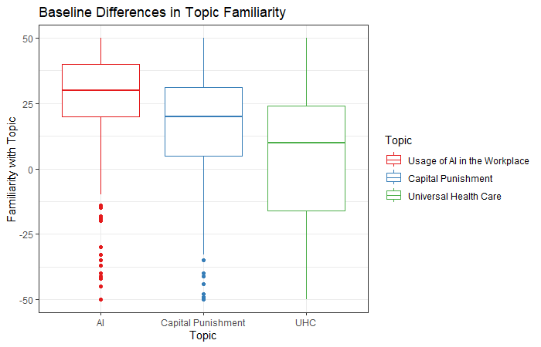

Our second one-way ANOVA revealed that there was a statistically significant difference in topic familiarity between at least two of our topics (*F* (2, 1470) = 132.7, *p* < .001). A post hoc Tukey test showed that all three of our topics had significant differences in topic familiarity at p < .05. We found that, contrary to *a-priori* expectations, our study sample self-reported the greatest familiarity with the topic of AI in the workplace, less familiarity with capital punishment, and even less with UHC. Qualitatively, the mean score for AI familiarity falls firmly in the range of ‘moderately’ familiar, which is unexpected, given the relative novelty of the field of AI as a whole (as compared to universal health care, or capital punishment, which has been in existence for decades).

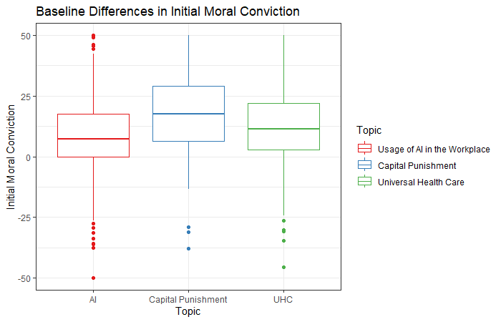

Our third one-way ANOVA revealed that there was a statistically significant difference in the initial level of moral conviction between at least two of our topics (*F* (2, 1470) = 62.12, *p* < .001). A post hoc Tukey test showed that all three of our topics had significant differences in baseline moral conviction at p < .05. As compared to our exploratory analysis in Study 2, none of our chosen topics were seen as lacking moral conviction (e.g., the exercise topic in Study 2 had a mean-value of 0 on the initial moral conviction scale). Additionally, we found that usage of AI in the workplace was held with the lowest, but still not nonzero amount of conviction, as compared to our other two topics.

***Discussion***

The results for Study 2 provide evidence of two main points. First, we were able to find that in some cases, our moral conviction manipulation had a significant interaction with openness to belief change, predicting increased support for a [Topic]. However, this evidence was mixed, as our moral conviction manipulation itself did not have a main effect on support for a [topic]. Notably, we did see that openness to belief change did have a significant main effect. Secondly, we found mixed evidence supporting H2, namely, that while our moral conviction manipulation did not directly affect moral conviction towards [topic], the individual difference of greater openness to change did accurately predict increased moral conviction. Additionally, our exploratory analyses replicated previous findings by Wright and colleagues, indicating that exercise is a topic not generally viewed with moral conviction, and that climate change, capital punishment, and universal health care are. Furthermore, we found a novel result indicating that the topic of UHC had significantly greater openness to belief change.

Given that we were able to successfully find a non-polarized topic for comparison, the next step is to empirically test the relationship between moral conviction and social consensus. Specifically, we wish to see if we can increase the effectiveness of social consensus by decreasing moral conviction, and conversely, if we can experimentally ‘inoculate’ individuals against the effect of social consensus by increasing their perceived moral conviction. Additionally, given that we plan to manipulate social consensus and moral conviction, we also plan to test if the results of Studies 1 and 2 are able to successfully replicate. With this issue in mind (empirically testing the relationship between social consensus and moral conviction), Study 3 was initiated.

# References

Akram, F. (2021). Moral injury and the COVID-19 pandemic: A philosophical viewpoint. *Ethics, Medicine and Public Health*, *18*, 100661. <https://doi.org/10.1016/j.jemep.2021.100661>

Albarracin, D., Johnson, B. T., Zanna, M. P., & Kumkale, G. T. (n.d.). *Attitudes: Introduction and Scope*.

Albarracin, D., & Shavitt, S. (2017). *Attitudes and Attitude Change*.

Alspaugh, A., Lanshaw, N., Kriebs, J., & Van Hoover, C. (2021). Universal Health Care for the United States: A Primer for Health Care Providers. *Journal of Midwifery & Women’s Health*, *66*(4), 441–451. <https://doi.org/10.1111/jmwh.13233>

Aramovich, N. P., Lytle, B. L., & Skitka, L. J. (2012). Opposing torture: Moral conviction and resistance to majority influence. *Social Influence*, *7*(1), 21–34. <https://doi.org/10.1080/15534510.2011.640199>

Asch, S. E. (1956). Studies of independence and conformity: I. A minority of one against a unanimous majority. *Psychological Monographs: General and Applied*, *70*(9), 1–70. <https://doi.org/10.1037/h0093718>

Béland, D., Rocco, P., & Waddan, A. (2016). Obamacare and the Politics of Universal Health Insurance Coverage in the United States. *Social Policy & Administration*, *50*(4), 428–451. <https://doi.org/10.1111/spol.12237>

Bizer, G. Y., & Krosnick, J. A. (2001). Exploring the structure of strength-related attitude features: The relation between attitude importance and attitude accessibility. *Journal of Personality and Social Psychology*, *81*(4), 566–586. <https://doi.org/10.1037/0022-3514.81.4.566>

Brady, F. N., & Wheeler, G. E. (1996). An empirical study of ethical predispositions. *Journal of Business Ethics*, *15*(9), 927–940. <https://doi.org/10.1007/BF00705573>

Carpenter, C. (2012). Functional Attitude Theory. In J. Dillard & L. Shen, *The SAGE Handbook of Persuasion: Developments in Theory and                    Practice* (pp. 104–119). SAGE Publications, Inc. <https://doi.org/10.4135/9781452218410.n7>

Chaiken, S., & Trope, Y. (Eds.). (1999). *Dual-process theories in social psychology*. Guilford Press.

Chen, S., Duckworth, K., & Chaiken, S. (1999). Motivated Heuristic and Systematic Processing. *Psychological Inquiry*, *10*(1), 44–49. <https://doi.org/10.1207/s15327965pli1001_6>

Clifford, S. (2019). How Emotional Frames Moralize and Polarize Political Attitudes. *Political Psychology*, *40*(1), 75–91. <https://doi.org/10.1111/pops.12507>

Cole Wright, J., Cullum, J., & Schwab, N. (2008). The Cognitive and Affective Dimensions of Moral Conviction: Implications for Attitudinal and Behavioral Measures of Interpersonal Tolerance. *Personality and Social Psychology Bulletin*, *34*(11), 1461–1476. <https://doi.org/10.1177/0146167208322557>

Crano, W. D., & Prislin, R. (2006). Attitudes and Persuasion. *Annual Review of Psychology*, *57*(1), 345–374. <https://doi.org/10.1146/annurev.psych.57.102904.190034>

Dalen, J. E., Waterbrook, K., & Alpert, J. S. (2015). Why do so Many Americans Oppose the Affordable Care Act? *The American Journal of Medicine*, *128*(8), 807–810. <https://doi.org/10.1016/j.amjmed.2015.01.032>

Davis, W., & Davis, W. (2020). Antarctic Winds: Pacemaker of Global Warming, Global Cooling, and the Collapse of Civilizations. *Climate*, *8*(11), 130. <https://doi.org/10.3390/cli8110130>

De Dreu, C. K. W., & West, M. A. (2001). Minority dissent and team innovation: The importance of participation in decision making. *Journal of Applied Psychology*, *86*(6), 1191–1201. <https://doi.org/10.1037/0021-9010.86.6.1191>

Deutsch, M., & Gerard, H. B. (1955). A study of normative and informational social influences upon individual judgment. *The Journal of Abnormal and Social Psychology*, *51*(3), 629–636. <https://doi.org/10.1037/h0046408>

DiJulio, Bianca, Firth, Jamie, & Brodie, Mollyann. (2014). *Kaiser Health Policy Tracking Poll: December 2014*. <https://www.kff.org/affordable-care-act/poll-finding/kaiser-health-policy-tracking-poll-december-2014/>

Eagly, A. H., & Chaiken, S. (1993). *The psychology of attitudes*. Harcourt Brace Jovanovich College Publishers.

El Hedhli, K., & Zourrig, H. (2023). Dual routes or a one-way to persuasion? The elaboration likelihood model versus the unimodel. *Journal of Marketing Communications*, *29*(5), 433–454. <https://doi.org/10.1080/13527266.2022.2034033>

Farrow, C. V., & Tarrant, M. (2009). Weight-based discrimination, body dissatisfaction and emotional eating: The role of perceived social consensus. *Psychology & Health*, *24*(9), 1021–1034. <https://doi.org/10.1080/08870440802311348>

Faul, F., Erdfelder, E., Buchner, A., & Lang, A.-G. (2009). Statistical power analyses using G*Power 3.1: Tests for correlation and regression analyses. *Behavior Research Methods*, *41*(4), 1149–1160. <https://doi.org/10.3758/BRM.41.4.1149>

Faul, F., Erdfelder, E., Lang, A.-G., & Buchner, A. (2007). G*Power 3: A flexible statistical power analysis program for the social, behavioral, and biomedical sciences. *Behavior Research Methods*, *39*(2), 175–191. <https://doi.org/10.3758/BF03193146>

Finegold, K., Conmy, A., Chu, R. C., Bosworth, A., & Sommers, B. D. (2021). *TRENDS IN THE U.S. UNINSURED POPULATION, 2010-2020*.

Frankford, D. M. (2015). The Remarkable Staying Power of “Death Panels.” *Journal of Health Politics, Policy and Law*, *40*(5), 1087–1101. <https://doi.org/10.1215/03616878-3161212>

Galvani, A. P., Durham, D. P., Vermund, S. H., & Fitzpatrick, M. C. (2017). California Universal Health Care Bill: An economic stimulus and life-saving proposal. *The Lancet*, *390*(10106), 2012–2014. <https://doi.org/10.1016/S0140-6736(17)32148-7>

Gibson, J. (2023). *Replication Data for: Losing Legitimacy: The Challenges of the Dobbs Ruling to Conventional Legitimacy Theory* [Dataset]. Harvard Dataverse. <https://doi.org/10.7910/DVN/AO7IYJ>

Goldberg, M. H. (n.d.). Perceived Social Consensus Can Reduce Ideological Biases on Climate Change. *Environment and Behavior*.

Gordon, Erron (Director). (2018, January 28). *President Trump—The Piers Morgan Interview* [Special]. ITV.

Greenwald, A. G., & Banaji, M. R. (n.d.). *Implicit Social Cognition: Attitudes, Self-Esteem, and Stereotypes*.

Greenwald, A. G., McGhee, D. E., & Schwartz, J. L. K. (n.d.). *Measuring Individual Differences in Implicit Cognition: The Implicit Association Test*.

Himmelstein, D. U., Warren, E., Thorne, D., & Woolhandler, S. (2005). Illness And Injury As Contributors To Bankruptcy: Even universal coverage could leave many Americans vulnerable to bankruptcy unless such coverage was more comprehensive than many current policies. *Health Affairs*, *24*(Suppl1), W5-63-W5-73. <https://doi.org/10.1377/hlthaff.W5.63>

Hodson, G., Maio, G. R., & Esses, V. M. (2001). The Role of Attitudinal Ambivalence in Susceptibility to Consensus Information. *Basic and Applied Social Psychology*, *23*(3), 197–205. <https://doi.org/10.1207/S15324834BASP2303_6>

Holland, R. W., Verplanken, B., & Van Knippenberg, A. (2003). From repetition to conviction: Attitude accessibility as a determinant of attitude certainty. *Journal of Experimental Social Psychology*, *39*(6), 594–601. <https://doi.org/10.1016/S0022-1031(03)00038-6>

Hsiao, W. C., Cheng, S.-H., & Yip, W. (2019). What can be achieved with a single-payer NHI system: The case of Taiwan. *Social Science & Medicine*, *233*, 265–271. <https://doi.org/10.1016/j.socscimed.2016.12.006>

Jia, K. M., Hanage, W. P., Lipsitch, M., Johnson, A. G., Amin, A. B., Ali, A. R., Scobie, H. M., & Swerdlow, D. L. (2023). Estimated preventable COVID-19-associated deaths due to non-vaccination in the United States. *European Journal of Epidemiology*, *38*(11), 1125–1128. <https://doi.org/10.1007/s10654-023-01006-3>

Jones, T. M. (2023). *Ethical Decision Making by Individuals in Organizations: An Issue-Contingent Model*.

Jung, C. G. (1923). *Psychological types or the psychology of individuation.* Harcourt, Brace.

Kassin, S. M., & Kiechel, K. L. (1996). The Social Psychology of False Confessions: Compliance, Internalization, and Confabulation. *Psychological Science*, *7*(3), 125–128. <https://doi.org/10.1111/j.1467-9280.1996.tb00344.x>

Kasten, M. (n.d.). *An Economic Analysis of the Death Penalty*.

Kidder, C. K. (n.d.). *DEFINING MORAL ATTITUDES: AN EXAMINATION OF THE STRUCTURE AND CONSEQUENCES OF MORAL ATTITUDES*.

Kobayashi, K. (2018). The Impact of Perceived Scientific and Social Consensus on Scientific Beliefs. *Science Communication*, *40*(1), 63–88. <https://doi.org/10.1177/1075547017748948>

Kodapanakkal, R. I., Brandt, M. J., Kogler, C., & Van Beest, I. (2022). Moral Frames Are Persuasive and Moralize Attitudes; Nonmoral Frames Are Persuasive and De-Moralize Attitudes. *Psychological Science*, *33*(3), 433–449. <https://doi.org/10.1177/09567976211040803>

Kruglanski, A. W., & Thompson, E. P. (1999). Persuasion by a Single Route: A View From the Unimodel. *Psychological Inquiry*, *10*(2), 83–109. <https://doi.org/10.1207/S15327965PL100201>

Kutlaca, M., Van Zomeren, M., & Epstude, K. (2016). Preaching to, or Beyond, the Choir: The Politicizing Effects of Fitting Value-Identity Communication in Ideologically Heterogeneous Groups. *Social Psychology*, *47*(1), 15–28. <https://doi.org/10.1027/1864-9335/a000254>

Lee, S. K., Sun, J., Jang, S., & Connelly, S. (2022). Misinformation of COVID-19 vaccines and vaccine hesitancy. *Scientific Reports*, *12*(1), 13681. <https://doi.org/10.1038/s41598-022-17430-6>

Love, E., Salinas, T. C., & Rotman, J. D. (2020). The Ethical Standards of Judgment Questionnaire: Development and Validation of Independent Measures of Formalism and Consequentialism. *Journal of Business Ethics*, *161*(1), 115–132. <https://doi.org/10.1007/s10551-018-3937-8>

Maheswaran, D., Mackie, D. M., & Chaiken, S. (1992). Brand name as a heuristic cue: The effects of task importance and expectancy confirmation on consumer judgments. *Journal of Consumer Psychology*, *1*(4), 317–336. <https://doi.org/10.1016/S1057-7408(08)80058-7>

Morris, N. S., MacLean, C. D., Chew, L. D., & Littenberg, B. (2006). The Single Item Literacy Screener: Evaluation of a brief instrument to identify limited reading ability. *BMC Family Practice*, *7*(1), 21. <https://doi.org/10.1186/1471-2296-7-21>

National Oceanic and Atmospheric Administration. (n.d.). *Snowfall Extremes—Missouri* [Dataset].

Newport, F. (2015). *In U.S., Percentage Saying Vaccines Are Vital Dips Slightly*. Gallup.

O’Keefe, D. J. (2016). Persuasion and Social Influence. In K. B. Jensen, E. W. Rothenbuhler, J. D. Pooley, & R. T. Craig (Eds.), *The International Encyclopedia of Communication Theory and Philosophy* (1st ed., pp. 1–19). Wiley. <https://doi.org/10.1002/9781118766804.wbiect067>

Panpiemras, J., Puttitanun, T., Samphantharak, K., & Thampanishvong, K. (2011). Impact of Universal Health Care Coverage on patient demand for health care services in Thailand. *Health Policy*, *103*(2–3), 228–235. <https://doi.org/10.1016/j.healthpol.2011.08.008>

Papanicolas, I., Woskie, L. R., & Jha, A. K. (2018). Health Care Spending in the United States and Other High-Income Countries. *JAMA*, *319*(10), 1024. <https://doi.org/10.1001/jama.2018.1150>

Pew Research Center. (2020). *2020 PEW RESEARCH CENTER’S AMERICAN TRENDS PANEL WAVE 71* [Dataset].

Pincus, M., LaViers, L., Prietula, M. J., & Berns, G. (2014). The Conforming Brain and Deontological Resolve. *PLOS ONE*, *9*(8).

Rest, J., Narvaez, D., Bebeau, M., & Thoma, S. (1999). A neo-Kohlbergian approach: The DIT and schema theory. *Educational Psychology Review*, *11*(4), 291–324. <https://doi.org/10.1023/A:1022053215271>

Richard, M.-O., & Chebat, J.-C. (2016). Modeling online consumer behavior: Preeminence of emotions and moderating influences of need for cognition and optimal stimulation level. *Journal of Business Research*, *69*(2), 541–553. <https://doi.org/10.1016/j.jbusres.2015.05.010>

Rocke, D. J., Thomas, S., Puscas, L., & Lee, W. T. (2014). Physician Knowledge of and Attitudes toward the Patient Protection and Affordable Care Act. *Otolaryngology–Head and Neck Surgery*, *150*(2), 229–234. <https://doi.org/10.1177/0194599813515839>

Rozin, P. (1999). The Process of Moralization. *Psychological Science*, *10*(3), 218–221. <https://doi.org/10.1111/1467-9280.00139>

Schoen, C., Doty, M. M., Collins, S. R., & Holmgren, A. L. (2005). Insured But Not Protected: How Many Adults Are Underinsured?: The experiences of adults with inadequate coverage mirror those of their uninsured peers, especially among the chronically ill. *Health Affairs*, *24*(Suppl1), W5-289-W5-302. <https://doi.org/10.1377/hlthaff.W5.289>

Schuldt, J. P., Konrath, S. H., & Schwarz, N. (2011). “Global warming” or “climate change”?: Whether the planet is warming depends on question wording. *Public Opinion Quarterly*, *75*(1), 115–124. <https://doi.org/10.1093/poq/nfq073>

Siegler, R. S., Thompson, C. A., & Schneider, M. (2011). An integrated theory of whole number and fractions development. *Cognitive Psychology*, *62*(4), 273–296. <https://doi.org/10.1016/j.cogpsych.2011.03.001>

Skitka, L. J. (2010). The Psychology of Moral Conviction: Moral Conviction. *Social and Personality Psychology Compass*, *4*(4), 267–281. <https://doi.org/10.1111/j.1751-9004.2010.00254.x>

Skitka, L. J., Bauman, C. W., & Lytle, B. (2009). The Limits of Legitimacy: Morality as a Constraint on Deference to Authority. *SSRN Electronic Journal*. <https://doi.org/10.2139/ssrn.1493520>

Skitka, L. J., Bauman, C. W., & Sargis, E. G. (2005). Moral Conviction: Another Contributor to Attitude Strength or Something More? *Journal of Personality and Social Psychology*, *88*(6), 895–917. <https://doi.org/10.1037/0022-3514.88.6.895>

Skitka, L. J., Hanson, B. E., Morgan, G. S., & Wisneski, D. C. (n.d.). *The Psychology of Moral Conviction*.

Skitka, L. J., & Morgan, G. S. (2014). The Social and Political Implications of Moral Conviction. *Political Psychology*, *35*(S1), 95–110. <https://doi.org/10.1111/pops.12166>

Skitka, L. J., Washburn, A. N., & Carsel, T. S. (2015). The psychological foundations and consequences of moral conviction. *Current Opinion in Psychology*, *6*, 41–44. <https://doi.org/10.1016/j.copsyc.2015.03.025>

Skitka, L. J., Wisneski, D. C., & Brandt, M. J. (2018). Attitude Moralization: Probably Not Intuitive or Rooted in Perceptions of Harm. *Current Directions in Psychological Science*, *27*(1), 9–13. <https://doi.org/10.1177/0963721417727861>

Smith, M. J., Ellenberg, S. S., Bell, L. M., & Rubin, D. M. (2008). Media Coverage of the Measles-Mumps-Rubella Vaccine and Autism Controversy and Its Relationship to MMR Immunization Rates in the United States. *Pediatrics*, *121*(4), e836–e843. <https://doi.org/10.1542/peds.2007-1760>

Stangor, C., Sechrist, G. B., & Jost, J. T. (2001). Changing Racial Beliefs by Providing Consensus Information. *Personality and Social Psychology Bulletin*, *27*(4), 486–496. <https://doi.org/10.1177/0146167201274009>

Steiker, C. S. (n.d.). NO, CAPITAL PUNISHMENT IS NOT MORALLY REQUIRED: DETERRENCE, DEONTOLOGY, AND THE DEATH PENALTY. *STANFORD LAW REVIEW*, *58*.

Täuber, S., & Van Zomeren, M. (2013). Outrage towards whom? Threats to moral group status impede striving to improve via out‐group‐directed outrage. *European Journal of Social Psychology*, *43*(2), 149–159. <https://doi.org/10.1002/ejsp.1930>

Thomas, W. I., Znaniecki, F., & Zaretsky, E. (1984). *The Polish peasant in Europe and America*. University of Illinois press.

Trump, D. J. (Guest). (n.d.). *2016 Republican Party Presidental Debate* [Broadcast].

Tseng, P.-E., & Wang, Y.-H. (2021). Deontological or Utilitarian? An Eternal Ethical Dilemma in Outbreak. *International Journal of Environmental Research and Public Health*, *18*(16), 8565. <https://doi.org/10.3390/ijerph18168565>

Tversky, A., & Kahneman, D. (1974). Judgment under Uncertainty: Heuristics and Biases: Biases in judgments reveal some heuristics of thinking under uncertainty. *Science*, *185*(4157), 1124–1131. <https://doi.org/10.1126/science.185.4157.1124>

Twenge, J. M., & Campbell, W. K. (2018). Associations between screen time and lower psychological well-being among children and adolescents: Evidence from a population-based study. *Preventive Medicine Reports*, *12*, 271–283. <https://doi.org/10.1016/j.pmedr.2018.10.003>

Van Bavel, J. J., Jenny Xiao, Y., & Cunningham, W. A. (2012). Evaluation is a Dynamic Process: Moving Beyond Dual System Models. *Social and Personality Psychology Compass*, *6*(6), 438–454. <https://doi.org/10.1111/j.1751-9004.2012.00438.x>

Van Harreveld, F., Van Der Pligt, J., De Vries, N. K., Wenneker, C., & Verhue, D. (2004). Ambivalence and information integration in attitudinal judgment. *British Journal of Social Psychology*, *43*(3), 431–447. <https://doi.org/10.1348/0144666042037971>

Wagner, J. M., & Dahnke, M. D. (2015). Nursing Ethics and Disaster Triage: Applying Utilitarian Ethical Theory. *Journal of Emergency Nursing*, *41*(4), 300–306. <https://doi.org/10.1016/j.jen.2014.11.001>

Weaver, J. R., & Bosson, J. K. (2011). I Feel Like I Know You: Sharing Negative Attitudes of Others Promotes Feelings of Familiarity. *Personality and Social Psychology Bulletin*, *37*(4), 481–491. <https://doi.org/10.1177/0146167211398364>

Welch, Susan, & Sigelman, Lee. (n.d.). The “Obama Effect” and White Racial Attitudes. *The ANNALS of the American Academy of Politcal and Social Science*, *634*(1). <https://doi.org/10.1177/000271621038630>

Wisneski, D. C., Hanson, B. E., & Morgan, G. S. (2020). The roles of disgust and harm perception in political attitude moralization. *Politics and the Life Sciences*, *39*(2), 215–227. <https://doi.org/10.1017/pls.2020.22>

World Health Organization. (2014). *Making fair choices on the path to universal health coverage: Final report of the WHO consultative group on equity and universal health coverage*. World Health Organization. <https://iris.who.int/handle/10665/112671>

# Appendices

## Appendix A – Materials for Study 1

### Cover Letter

**[Social Memory and Recollection on Current and Past Issues]**  
  
**Key Information About the Study:**  
  
You are being asked to participate in a research study. The purpose of the research study is to examine what characteristics issues, and the individuals assessing those issues, have in determining the accuracy of recollection. You are being asked for this study to predict what you believe American public sentiment in 2018 was on several social and scientific issues. Possible benefits include an improved understanding of how social perception can change over time, as well as concrete information on what American public perception in 2018 was like on several critical issues that are still relevant today. Some possible risks may include discomfort from the participant if they feel strongly about and or disagree with what was surveyed to be American public opinion in 2018 on several issues.  
  
Please read this form carefully and take your time. Let us know if you have any questions before participating. The research team can explain words or information that you do not understand. Research is voluntary and you can choose not to participate. If you do not want to participate or choose to start then stop later, there will be no penalty or loss of benefits to which you are otherwise entitled.  
  
**Purpose of the Research**  
You are being asked to participate in this study because we believe that assessing what characteristics in both issues and individuals predict accurate recollection of factual information has great value. The purpose of the study is to determine if and what these potential characteristics that affect accuracy of memory recall are. What will happen during the study? You are being be asked to participate in a online survey. Specifically, we will ask you to predict the extent to which the American public, in 2018, agreed or disagreed with various social and scientific issues. We will also assess individual differences, including moral beliefs, numeracy, and demographic information.  
  
Your participation is expected to last less than 30 minutes.  
  
**What are the expected benefits of the study?**  
We believe the main direct benefit to an individual will be the educational benefit of having accurate understanding of American public opinion, circa 2018. Furthermore, we believe that there will be indirect benefits to society as a whole by gleaning a greater understanding of what characteristics improve memory recall. Ideally, this could lead to media coverage of pertinent events being even more easily memorable to the general public, enhancing mass understanding of contemporary issues.  
  
**What are the possible risks of participating in this study?**  
  
There are minimal risks expected when taking part in this study. The most likely risk will be discomfort if our participant strongly disagrees with the information on American public opinion that we have presented. To help lower these possible risks, we will ensure that the information on American public opinion, circa 2018, accurately reflects what we believe to be the ‘true’ state of social consensus on these issues at that time. We will tell you about any new information we learn that may affect your decision to continue to participate in this study.  
  
**What other choices do I have if I don’t want to be in this study?**  
  
You are not required to be in this study. You can simply choose not to participate. You can look for other research projects you may be interested in instead of this study. You can obtain any number of required Psychology 1000 research credits by instead writing an essay and submitting it to your primary instructor, for each research credit you would like to replace.  
  
**Will I receive compensation for taking part in this study?**  
  
You will be compensated for taking part in this study. For your time and effort, you will receive one research credit for participating in the study. If you choose not to participate in this study, you can still receive the credits by writing an essay on a pre-determined selection of topics (please see your instructor for details).  
  
**Will information about me be kept private?**  
  
The research team is committed to respecting your privacy and keeping your personal information anonymous. We will make every effort to protect your information to the extent allowed by law. When the results of this research are shared, since there is no identifying information it will not be known who provided the information. Your information will be kept as secure as possible to prevent your identity from being disclosed. What we collected from you as part of this research will not be used or shared for future research studies. It will only be used for purposes of this study. We may share what we collected from you as part of this research, for future research without additional informed consent from you.  
  
**Who do I contact if I have questions or concerns?**  
  
If you have questions about this study or experience a research-related injury, you can contact the Primary Investigator at sxdff5@mail.missouri.edu, or at 573-882-6860. If you have questions about your rights as a research participant, please contact the University of Missouri Institutional Review Board (IRB) at 573-882-3181 or muresearchirb@missouri.edu. The IRB is a group of people who review research studies to make sure the rights and welfare of participants are protected. If you want to talk privately about any concerns or issues related to your participation, you may contact the Research Participant Advocacy at 888-280-5002 (a free call) or email muresearchrpa@missouri.edu.  
  
**Do I get a copy of this consent?**  
  
You can ask the researcher to provide you with a copy of this consent for your records, or you can save a copy of this consent if it has already been provided to you. We appreciate your consideration to participate in this study.

### Debrief

**Impact of Social Consensus on Support for Universal Health Care**

Dear Participant,

During this study, you were asked to predict what public approval in 2018 was for several scientific and social issues, as well as to estimate what it would be in current (2023) times. Additionally, we asked you to rate your own level of agreement with the four aforementioned issues.

You were told that the purpose of the research study was to examine how individual differences affect the accuracy of recollections.

The actual purpose of the study was to investigate how various characteristics of social perception, as well as individual differences in people, could or would have a direct effect on support for Universal Health Care.

We did not tell you everything at the beginning of the study because we were trying to directly determine if outside perception of greater social consensus would 'over-ride' individual preferences one way or another for greater support of Universal Health Care. To describe in a simple way, we thought that if we could get you to believe that the general public was in favor of something (which we did by giving you the false feedback) you may become more likely to favor it.

If you have any concerns about your participation or the data you provided during the study, please discuss these concerns with us. We will be happy to provide you with any explanations or information to ease your concerns.

Of note, the actual values from real, recent surveys, circa 2017-2019 are provided below for your edification.  
  
**49%** of the American Public agrees that Greenhouse gas emissions generated by human activity has and will continue to change Earth's climate a great deal.

**63%** of the American Public agrees that the US government needs to implement Universal Health Care because basic population needs are not being met.

**60%** of the American Public agrees that Capital Punishment (the Death Penalty) is necessary in the US.

Additionally the question on "slavery, forced labor, and human trafficking are violations of human rights." was an entirely falsified question, placed at an obviously artificially high value to provide some calibration in social perception.

Now that you have been told the true purpose of the study, you have the option to have your data removed from the study. Please let the researcher know if you do not want your data to be used in this research and it will be removed.

**The responses in this study cannot be linked to you.**

We would like you to know that we really appreciate your time in helping with this research and are always happy to answer any questions that you might have about it. If you have any additional questions about the study, you can reach me by email at sxdff5@mail.missouri.edu. **Thank you, specifically**for your participation. Really, it helps out a ton!

- Sean Duan

If you have questions about your rights as a research participant or want to report a complaint, please contact the Institutional Review Board at the University of Missouri at 573-882-3181, 310 Jesse Hall, Columbia, MO 65211, or at umcresearchcirb@missouri.edu

### Measures

Ethical Standards of Judgement Questionnaire – Utilitarian Subscale

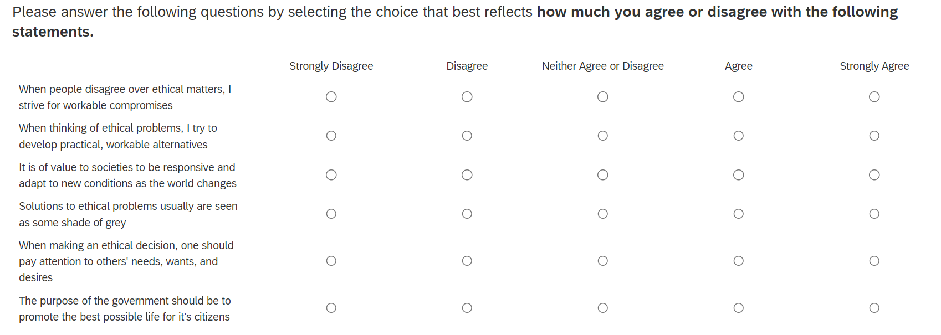

Ethical Standards of Judgement Questionnaire – Deontological Subscale

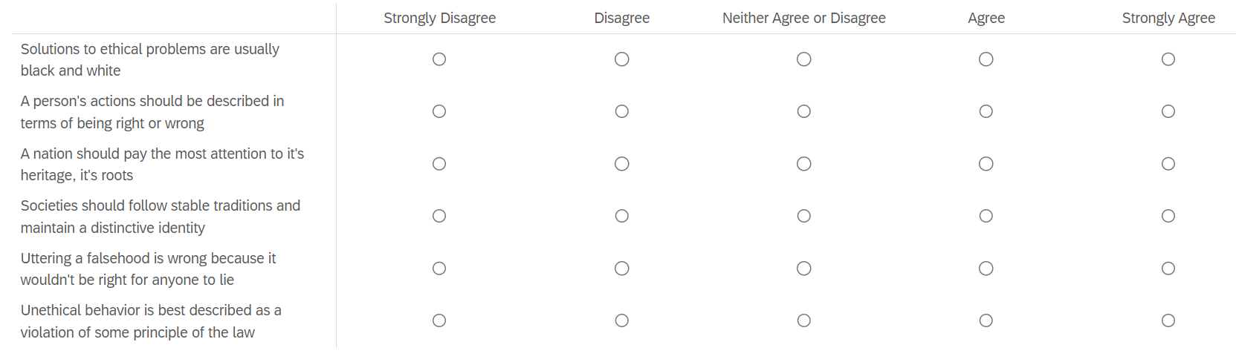

Primary Outcome Measure – Support for [Topic]

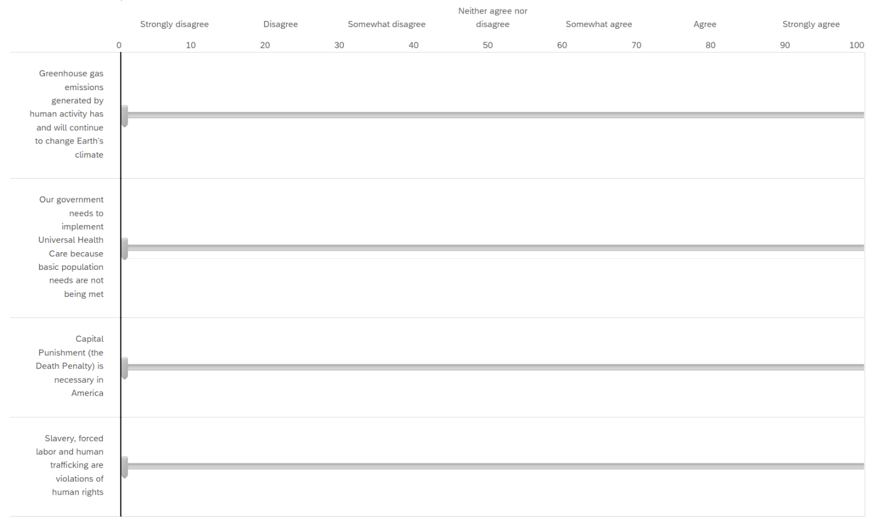

Level of Surprise at Public Survey Results

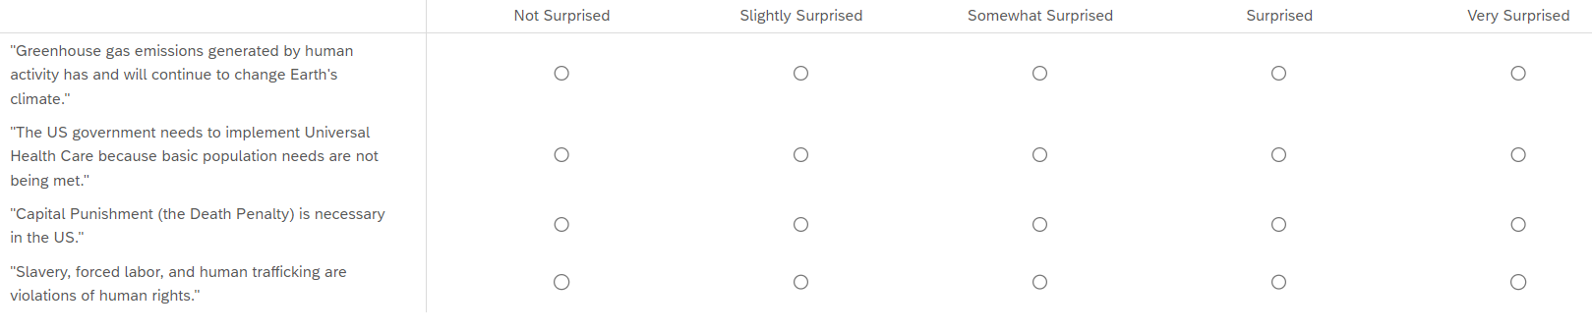

Single Item Health Literacy Screener



Subjective Numeracy Block

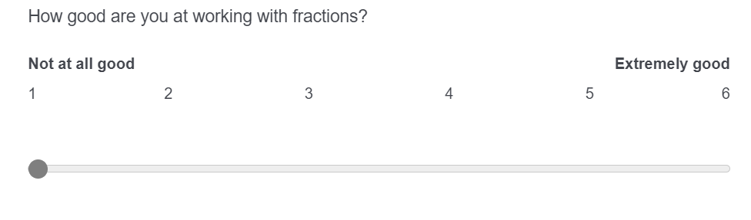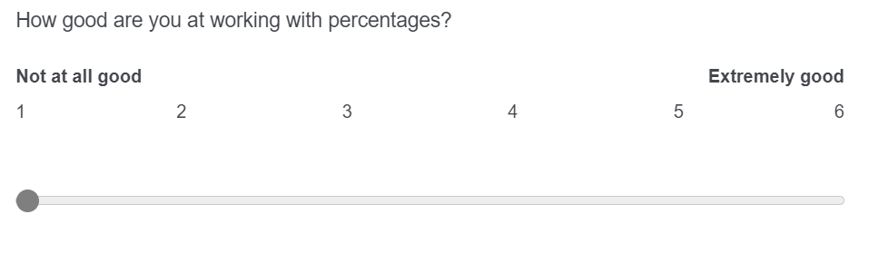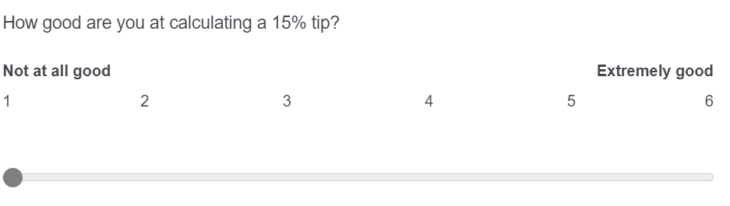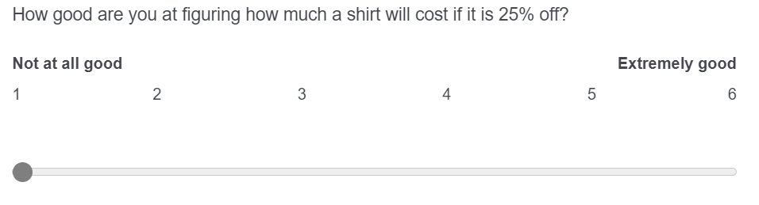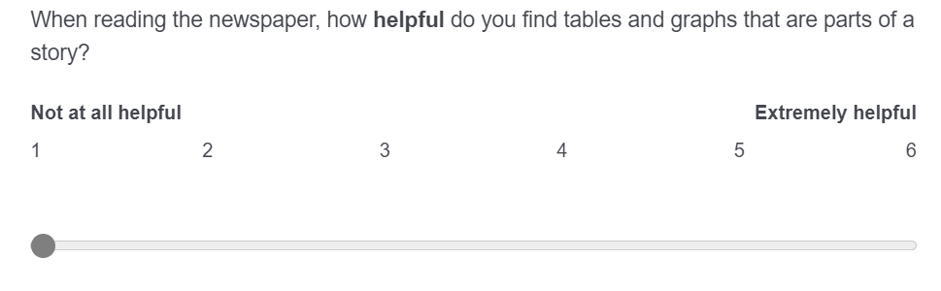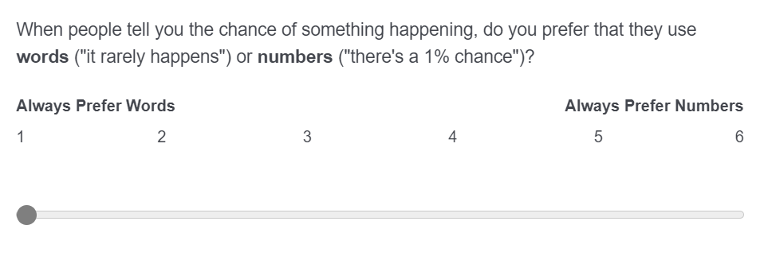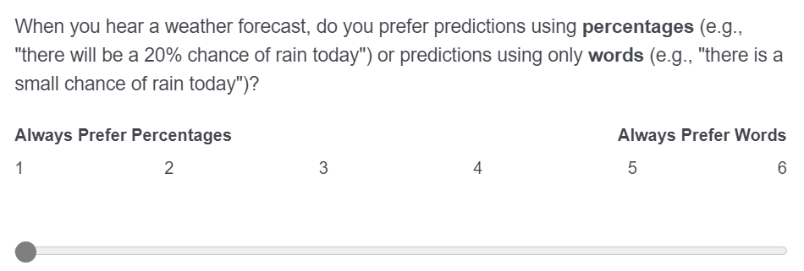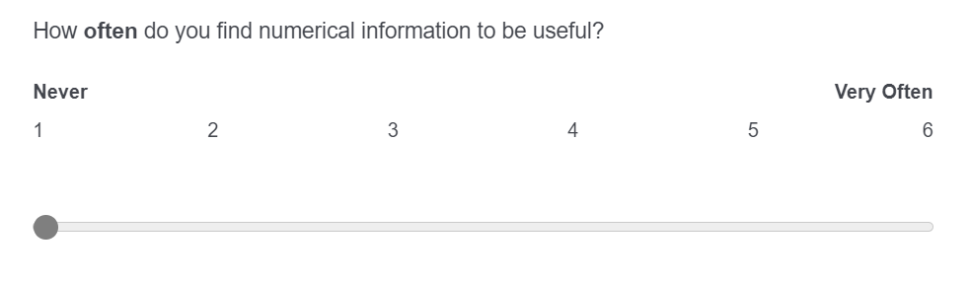

Objective Numeracy Block – Number Line Task

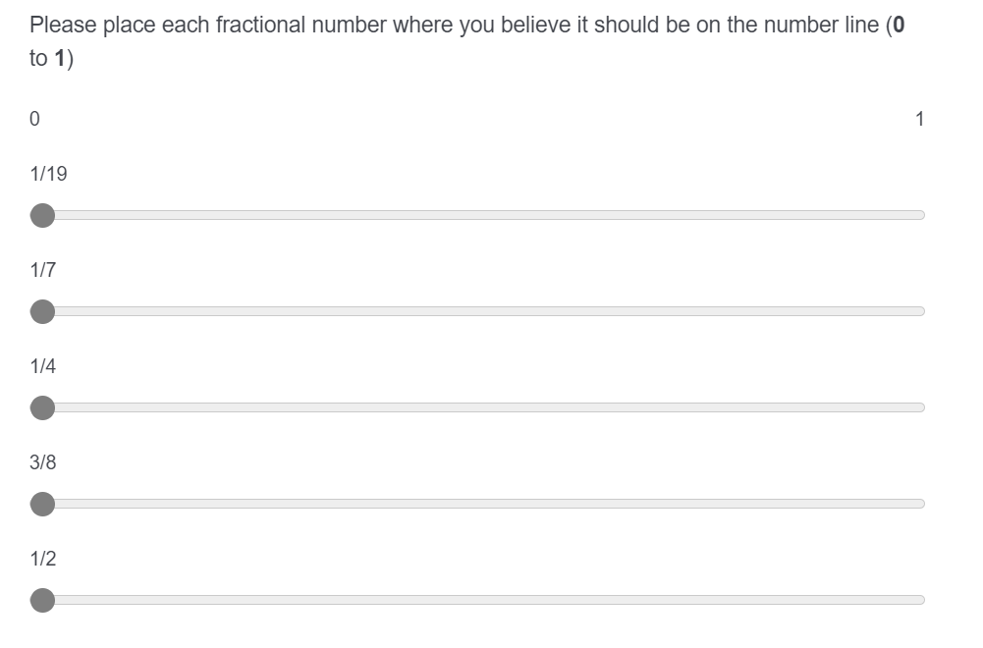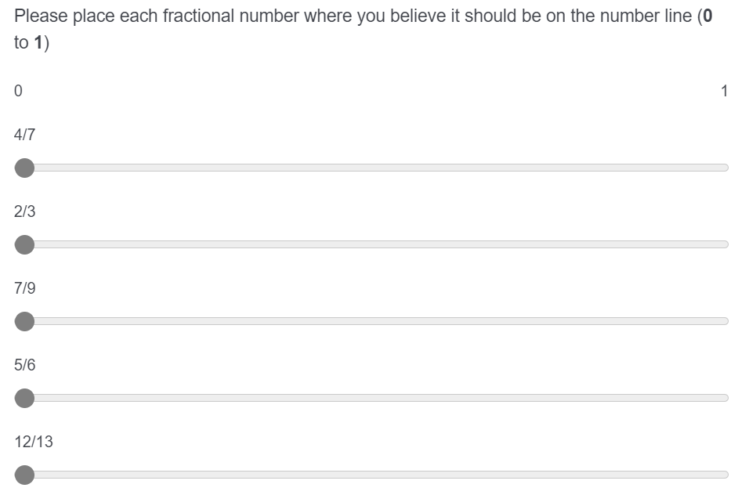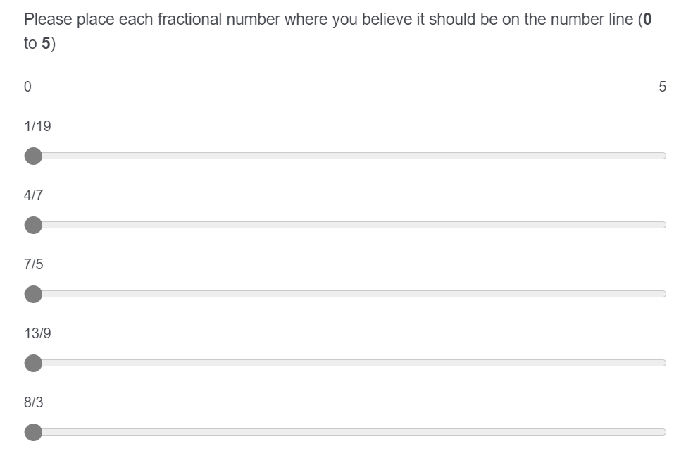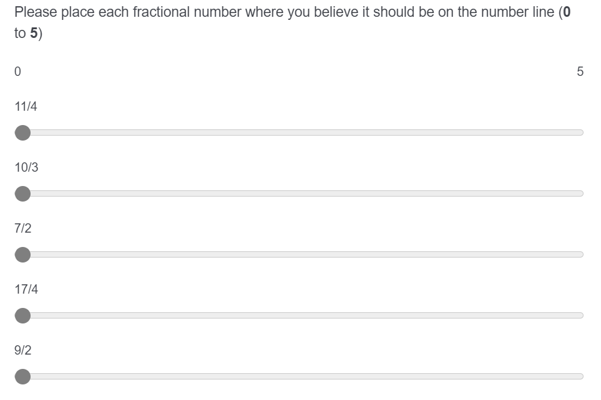

## Appendix B – Materials for Study 2

### Cover Letter

**[Perspectives on Current and Past Issues]**  
  
Sean X. Duan – IRB #2100125  
  
**Key Information About the Study:**  
  
You are being asked to participate in a research study. The purpose of the research study is to examine moral conviction and how that affects assessment of issues and decision-making around those issues. You are being asked for this study to read a few short essays and pamphlets detailing positions in favor or opposition for various topics. Possible benefits include an improved understanding of how moral conviction can change over time, as well as how this can interact with perceptions of each of these topics. Some possible risks may include discomfort from the participant if they feel strongly about and agree or disagree with the arguments either opposing or favoring the three topics we will cover.  
  
Please read this form carefully and take your time. Let us know if you have any questions before participating. The research team can explain words or information that you do not understand. Research is voluntary and you can choose not to participate. If you do not want to participate or choose to start then stop later, there will be no penalty or loss of benefits to which you are otherwise entitled.  
  
**Purpose of the Research**  
You are being asked to participate in this study because we believe that assessing how moral conviction and the saliency of that moral conviction can affect perception and decision-making has great value. The purpose of the study is to determine if we are able to directly affect the saliency of moral conviction, especially across various topics that are generally considered to have different moral weight. You are being asked to participate in a online survey. Specifically, we will ask you to read several short essays and pamphlets. We will also assess individual differences, including moral beliefs, numeracy, and demographic information.  
  
Your participation is expected to last less than 30 minutes.  
  
**What are the expected benefits of the study?**  
We believe the main direct benefit to an individual will be the educational benefit of having accurate understanding of how moral conviction affects decision making. Furthermore, we believe that there will be indirect benefits to society as a whole by gleaning a greater understanding of what level of inherent moral conviction our three topics contain.  
  
**What are the possible risks of participating in this study?**  
  
There are minimal risks expected when taking part in this study. The most likely risk will be discomfort if our participant strongly disagrees with the information on the three topics that we have presented. To help lower these possible risks, we will ensure that the information we portray on our topics is as accurate as possible. We will tell you about any new information we learn that may affect your decision to continue to participate in this study.  
  
**What other choices do I have if I don’t want to be in this study?**  
  
You are not required to be in this study. You can simply choose not to participate. You can look for other research projects you may be interested in instead of this study. You can obtain any number of required Psychology 1000 research credits by instead writing an essay and submitting it to your primary instructor, for each research credit you would like to replace.  
  
**Will I receive compensation for taking part in this study?**  
  
You will be compensated for taking part in this study. For your time and effort, you will receive one research credit for participating in the study. If you choose not to participate in this study, you can still receive the credits by writing an essay on a pre-determined selection of topics (please see your instructor for details).  
  
**Will information about me be kept private?**  
  
The research team is committed to respecting your privacy and keeping your personal information anonymous. We will make every effort to protect your information to the extent allowed by law. When the results of this research are shared, since there is no identifying information it will not be known who provided the information. Your information will be kept as secure as possible to prevent your identity from being disclosed. What we collected from you as part of this research will not be used or shared for future research studies. It will only be used for purposes of this study. We may share what we collected from you as part of this research, for future research without additional informed consent from you.  
  
**Who do I contact if I have questions or concerns?**  
  
If you have questions about this study or experience a research-related injury, you can contact the Primary Investigator at sxdff5@mail.missouri.edu, or at 573-882-6860. If you have questions about your rights as a research participant, please contact the University of Missouri Institutional Review Board (IRB) at 573-882-3181 or muresearchirb@missouri.edu. The IRB is a group of people who review research studies to make sure the rights and welfare of participants are protected. If you want to talk privately about any concerns or issues related to your participation, you may contact the Research Participant Advocacy at 888-280-5002 (a free call) or email muresearchrpa@missouri.edu.  
  
**Do I get a copy of this consent?**  
  
You can ask the researcher to provide you with a copy of this consent for your records, or you can save a copy of this consent if it has already been provided to you. We appreciate your consideration to participate in this study.

### Debrief

**[Perspectives on Current and Past Issues]**

This concludes the experiment. Thank you for participating in this study. I would like to take a few additional moments to tell you a little bit more about the research and why it is being conducted.

This research investigates several different theories of how best to change belief on topics that contain moral conviction. Now, what does this actually mean? In a simple sense, many people can have various reasons for choosing to support one thing or another, but not all reasoning is made equal.  
  
For example: some people would support abortion access simply because that's what the law is where they live - they don't think about it beyond that, and if the law changed, their stance would change. Some other people would support abortion access because that's what their friends, family, and neighbors believe - if they moved somewhere else, or their social circle changed their mind, their stance could change as well! However, there are definitely some people who support abortion access because they feel deep in their hearts, that it is the 'right' thing to do and is worth fighting for.  
  
Interestingly enough, this could go in both directions! There are people who would care to restrict abortion access that could feel that way for all three of these reasons.  
  
Some topics are generally more 'morally loaded' than others, and certainly not everyone agrees as to what topics are even up for ethical debate.  
  
We designed this experiment to examine if moral conviction is something that we could change, by providing either a highly moral argument that explicitly frames things through the 'lens' of harm and fairness, a highly moral argument that explicitly links the current concept to another, already accepted as moral belief (this is known as 'moral piggybacking'), a non-moral argument that emphasizes pragmatic elements such as cost or inefficiency, and a non-moral argument that emphasizes personal economic and hedonic benefits.  
  
Furthermore, we chose two topics that we assessed were along the spectrum of what the majority of people would consider worth moral consideration. Our most 'non-moral' topic was exercise, and our two most 'moral' topics were capital punishment (the death penalty) and climate change. We also chose to assess universal health care, as there is little prior research as to whether or not the public in general sees it as a moral topic, but there is plausible reasoning to believe that it has some moral weight.  
  
Our initial assumption is that a non-moral argument would be more persuasive than a moral one in changing the mind of someone who has high moral conviction on a topic, and that a moral argument would lead to greater 'polarization' (people who support, support even more, and people who hate it, hate it even more!) for those who have high moral conviction on the topic.  
  
We believe that understanding more deeply how moral conviction relates to perceptions of Universal Health Care will move us forward in our ability to change beliefs in circumstances of moral conviction as well as expanding our academic understanding of moral decision making more broadly.  
  
We would like you to know that we really appreciate your time in helping with this research and are always happy to answer any questions that you might have about it. We think that one way to understand medical decisions is by learning more about what was investigated today. If you have any additional questions about the study, you can reach me by email at sxdff5@mail.missouri.edu.  
  
**Thank you, specifically** for your participation. Really, it helps out a ton! - Sean Duan

 If you have questions about your rights as a research participant or want to report a complaint, please contact the Institutional Review Board at the University of Missouri at 573-882-3181, 310 Jesse Hall, Columbia, MO 65211, or at muresearchirb@missouri.edu

### Materials

Moral Responsibility Essay – Universal Health Care

**[Universal Health Care]**  
  
Some countries guarantee healthcare to all citizens for free through Universal Health Care (UHC). Just guaranteeing UHC through the law isn’t enough though. The big question is, who will pay for UHC?  
  
The answer is the U.S. government. The U.S. government has an obligation to fulfill its promise of life, liberty, and the pursuit of happiness. These guaranteed rights are a moral issue, and require good health.  
  
Individual health is the responsibility of every citizen. However, most normal Americans will experience an injury or illness that cannot be self-solved. Good health has no equivalent. You can choose not to replace a broken phone. However, skipping chemotherapy for cancer has a real ethical cost.  
  
Healthcare is expensive. Even hard-working Americans can struggle to get healthcare. Large healthcare costs could happen to anyone. American citizens ought to demand UHC from their government. This is a moral responsibility, helping all Americans pursue life, liberty, and happiness.

Moral Responsibility Essay – Capital Punishment

**[Capital Punishment]**  
  
In many countries, killing is used as punishment for a crime. This is known as capital punishment (or the death penalty). Should capital punishment be used in America?  
  
Many believe that because capital punishment is an ethical wrong, we should not use it.  
  
There is strong evidence that capital punishment in America is unfair and a moral issue. Juries can sometimes make mistakes. These mistakes lead to innocents dying. To many people, killing the innocent is an ethical problem. Executing the guilty is not worth the ethical mistake of executing the innocent.  
  
There is also a huge risk of racial bias in capital punishment. 42% of death row prisoners are African American. However, only 12.5% of our population is black. Also, killers of White Americans are sentenced to death at higher rates than killers of Black Americans. This racial bias is unjust.  
  
Capital punishment is wrong. Society pays large moral costs by killing innocent people. The clear racial bias in execution is ethically unacceptable. We cannot allow this to go on. America has to stop using capital punishment.

Moral Responsibility Essay – Exercising

**[Exercising]**  
  
Activities for physical fitness are known as exercise. One problem is that over 45% of American adults do not get enough exercise. Should Americans exercise more?  
  
One argument for exercise is that exercising grows moral character. Being healthy helps make connections with people. Exercise is a moral issue.  
  
America is a diverse country, and we don’t always agree. Taking care of your body is something that we can all agree on. When you exercise, you are getting healthy and living a more ethical life. Ignoring your own health and wellbeing has large moral costs.  
  
Wellness is a virtue. Exercise is good for you and moral. Americans should increase their exercise. Exercising is important for a morally correct society.

Moral Responsibility Essay – Climate Change

**[Climate Change]**  
  
Climate change is the process of our planet heating up. Some of this is due to normal processes like summertime, or volcanos. Most climate change is due to burning oil, gas, or coal. Should Americans reduce their climate impact?  
  
One position is that climate change is a moral issue. Climate change affects basic human rights. Americans in dry places are hurt when they don’t have enough water. Americans in wet places are hurt by natural disasters like hurricanes and typhoons. Americans in hot place are hurt by things like heatstroke. Americans everywhere are hurt when they can’t travel due to extreme weather. There is a real moral cost to all this hurt.  
  
Reducing climate change is easy. Recycling, carpooling, public transportation, and buying used items all help. It is a moral responsibility to do what you can. Helping your fellow Americans is ethically correct.

Moral Piggybacking Essay – Universal Health Care

**[Universal Health Care]**  
  
Some countries guarantee healthcare to all citizens for free through Universal Health Care (UHC). Just guaranteeing UHC through the law isn’t enough though. The big question is, who will pay for UHC?  
  
The answer is the U.S. government. UHC is important because it protects the value of human life. Healthcare is fundamental for protecting human life, and all citizens can agree that human life really matters.  
  
Most normal Americans will experience an injury or illness that cannot be self-solved. With UHC, we can protect these lives. Abandoning this ethical principle is dangerous. Other values are at risk if this happens. How can you have freedom of speech if you are badly sick?  
  
Good health has no equivalent. You can choose not to replace a broken phone. However, skipping chemotherapy for cancer is unacceptable if we value lives.  
  
Healthcare is expensive. Even hard-working Americans can struggle to get healthcare. Lives have real value. To protect American lives, we need UHC.

Moral Piggybacking Essay – Capital Punishment

**[Capital Punishment]**  
  
In many countries, killing is used as punishment for a crime. This is known as capital punishment (or the death penalty). Should capital punishment be used in America?  
  
Many believe that because capital punishment reduces the value of life, we should not use it.  
  
Most people agree that lives have value. Human life is precious and worth protecting. Capital punishment runs counter to this moral principle. Killing should be avoided because it is morally wrong to end life. Executing the guilty is not worth decreasing the value of human life. Harming others is not the goal of 'justice'. Abandoning the principles of sanctity of life is a slippery slope. Easily leading to sacrificing human lives and safety for profit.  
  
If protecting life is ethically important, then we cannot support the death penalty. Society bears large moral costs in doing so. The state-sanctioned ending of lives, regardless of the life, is ethically unacceptable. America needs to move past the usage of capital punishment.

Moral Piggybacking Essay – Exercising

**[Exercising]**  
  
Activities for physical fitness are known as exercise. One problem is that over 45% of American adults do not get enough exercise. Should Americans exercise more?  
  
We can first think about what is important to us. If exercise helps our important values, then we should do it. For example, discipline and responsibility matter. Exercise is useful for getting more of both! These values improve your health. Not exercising can lead to some negative values as well. Nobody wants to be lazy and unproductive! Exercise helps fight both of these. Keeping this all in mind, exercise leads to a better and more moral life.  
  
America is a diverse country, and we don’t always agree. Everyone likes responsible people. Discipline is also useful. These values are virtues. We agree that exercise helps achieve them. We also agree these values matter in our society. Thus, Americans ought to exercise more.

Moral Piggybacking Essay – Climate Change

**[Climate Change]**  
  
Climate change is the process of our planet heating up. Some of this is due to normal processes like summertime, or volcanos. Most climate change is due to burning oil, gas, or coal. Should Americans reduce their climate impact?  
  
One position is the importance of fairness. Most people agree that fairness really matters. The effects of climate change are hugely unfair. Americans in dry places are unfairly hurt when they don’t have enough water. Americans in wet places are unfairly hurt by hurricanes and typhoons. It is unfair to Americans everywhere when extreme weather makes it hard to travel.  
  
Reducing climate change is easy. Recycling, carpooling, public transportation, and buying used items all help. It is unfair to expect anyone to solve it alone. Helping out your fellow Americans proves how important fairness is to you.

Pragmatic/Practical Essay – Universal Health Care

**[Universal Health Care]**  
  
Some countries guarantee healthcare to all citizens for free through Universal Health Care (UHC). Just guaranteeing UHC through the law isn’t enough though. The big question is, who will pay for UHC?  
  
The answer is the U.S. government. The U.S. government already spends a significant amount of its gross domestic product on healthcare, totaling over 18.3% in 2022. In comparison, some of our peer countries with UHC like Canada (12.2%) and Japan (11%) spend a lot less. Surprisingly, our estimated lifespans are noticeably shorter (78.5 years, vs 82.6 and 84.45, for Canada and Japan).  
  
More healthcare coverage helps American citizens directly. UHC leads to lower healthcare costs, lower infant and maternal mortality, and better average health everywhere. The effects of an increase in healthcare access through statewide Medicaid expansion have already been seen. Compared to states that did not expand access, they eliminated catastrophic medical costs, lowered medical debt, lowered depression, and increased perception of health.  
  
Health care today costs too much, and America has been spending more money to get worse outcomes. This is unacceptable. American citizens should demand UHC from their government. That way, everyone can benefit from an increased life-span and a greater quality of life.

Pragmatic/Practical Essay – Capital Punishment

**[Capital Punishment]**  
  
In many countries, killing is used as punishment for a crime. This is known as capital punishment (or the death penalty). Should capital punishment be used in America?  
  
Many believe that because capital punishment doesn’t make economic sense, we should not use it.  
  
Capital punishment in America is expensive. Capital punishment cases need over twice as many hearings and court filings (20 and 65, as opposed to 10 and 29). Sentencing also takes a lot longer. Capital punishment cases need about 200 days more than other, similar cases. Our justice system cannot handle this inflated burden.  
  
This also leads to greater direct costs to taxpayers, at an estimated $800,000 – $1,000,000 more per offender, compared to the costs of life imprisonment. Capital punishment only gets more expensive every year, from approximately $1,100,000 in the 90’s, to over $1,700,000 today. This price rises much faster than the cost of life imprisonment. Going forward, this means even more monetary waste.  
  
If our economy is important, we cannot support the death penalty. Society bears large economic costs in doing so. The large increase in burden on both the courts and American taxpayers is economically unacceptable. America needs to move past the usage of capital punishment.

Pragmatic/Practical Essay – Exercising

**[Exercising]**  
  
Activities for physical fitness are known as exercise. One problem is that over 45% of American adults do not get enough exercise. Should Americans exercise more?  
  
Exercise has real practical benefits. Not exercising leads to a 30% higher rate of diabetes, and a 50% higher rate of hypertension. These serious illnesses are awful. Avoiding them is a smart choice. Having a higher quality of life is really worth it. Exercise can also be really cheap. Anyone can choose to walk more. Sit-ups and push-ups are free. Youtube has easy tutorials. Even using the stairs can help a little bit. Exercise is very practical.  
  
America is a diverse country, and we don’t agree on everything. Living longer is one thing we can all appreciate. You can live longer by exercising! Exercise reduces risk of death per year about 20-35%.  
  
Exercise is very practical and has obvious benefits. Exercise is for everyone, not just athletes or the rich. Thus, Americans should exercise more.

Pragmatic/Practical Essay – Climate Change

**[Climate Change]**  
  
Climate change is the process of our planet heating up. Some of this is due to normal processes like summertime, or volcanos. Most climate change is due to burning oil, gas, or coal. Should Americans reduce their climate impact?  
  
One perspective is the economic impact. Excess carbon costs about $51 per ton, in the form of reduced air and water quality, and extreme weather events. Carbon taxes in America set at $25 per ton leads to an estimated reduction of 10.5 gigatons of carbon per year. This $26 per ton net savings would result in $273 billion extra per year in the US economy. Reducing climate impact leads to a stronger economy.  
  
While each individual American citizen has their own obligations and responsibilities, a stronger economy benefits all Americans. Many climate change actions exist that can even save you money, such as carpooling or using public transportation when possible, and buying used items instead of new. Taking steps to reduce your climate change impact just makes economic sense.

Personal/Hedonic Essay – Universal Health Care

**[Universal Health Care]**  
  
Some countries guarantee healthcare to all citizens for free through Universal Health Care (UHC). Just guaranteeing UHC through the law isn’t enough though. The big question is, who will pay for UHC?  
  
The answer is the U.S. government. UHC is a clear winner and benefits ordinary Americans. Monthly average health insurance premiums already cost roughly $438 a month. If the U.S. government covered basic healthcare needs, you could be saving over $400 a month instead! Plus, it’s fun to not have to worry about healthcare expenses. Traveling to go on a ski-trip, or hiking in a national park is much more relaxing, and your costs are covered if you hurt yourself.  
  
The effects of an increase in healthcare access through statewide Medicaid expansion have already been seen. Compared to states that did not expand access, they eliminated catastrophic medical costs, lowered medical debt, lowered depression, and increased perception of health. It is obvious that you benefit directly from all of these things.  
  
Directly helping ordinary Americans is a significant part of why UHC matters. American citizens should demand UHC from their government. That way, you can benefit from more money in your own pocket, and an increased quality of life.

Personal/Hedonic Essay – Capital Punishment

**[Capital Punishment]**  
  
In many countries, killing is used as punishment for a crime. This is known as capital punishment (or the death penalty). Should capital punishment be used in America?  
  
Many believe because capital punishment doesn’t benefit themselves, we should not use it.  
  
Capital punishment in America affects taxes. The average cost of one execution is almost $2 million dollars. This means $150 dollars per year in extra taxes to fund these executions. For many people, $150 is a significant amount. Imagine if the government asked to raise your taxes $150 dollars per year, to pay for the execution of human life! Also, anyone could be accused of a serious crime. This includes you or your friends. You would also feel guilty if innocent people were killed. This guilt is easy to avoid by stopping the death penalty.  
  
The average American does not benefit from execution compared to life imprisonment. Execution leads to higher taxes . Overall, capital punishment doesn’t help anybody -- including you. America needs to move past the usage of capital punishment.

Personal/Hedonic Essay – Exercising

**[Exercising]**  
  
Activities for physical fitness are known as exercise. One problem is that over 45% of American adults do not get enough exercise. Should Americans exercise more?  
  
One simple argument in favor of exercise is that exercise is a great way to save money and feel good. Lack of exercise costs people $27 billion dollars annually. People who don’t exercise are also 64% more likely to be diagnosed with depression. Not exercising shrinks both your wallet and your happiness.  
  
America is a diverse country, and we don’t agree on everything. Lower medical costs and a more positive mood is something that we can all appreciate. Regular exercise can save you about $2,500 a year on medical costs! Exercise can also be really cheap. Anyone can choose to walk more. Sit-ups and push-ups are free. There aren’t a lot of ways to save money that have low or no upfront costs. Exercising is also really good for mental health. This is because exercise releases natural 'feel good' chemicals. These chemicals directly lead to mood and happiness improvements.  
  
Exercise can really improve your own quality of life. Americans should indeed take steps to increase their exercise, as this leads to better financial and mental health.

Personal/Hedonic Essay – Climate Change

**[Climate Change]**  
  
Climate change is the process of our planet heating up. Some of this is due to normal processes like summertime, or volcanos. Most climate change is due to burning oil, gas, or coal. Should Americans reduce their climate impact?  
  
One perspective is how climate change affects you directly. Millions of premature deaths occur every year due to air pollution. Nobody wants to live in a place where the air smells awful and is hard to breathe. Americans can also enjoy majestic natural parks (Yellowstone, Yosemite, Glacier, etc.). Climate change and pollution could lead to these parks being closed to the public in the future. Iconic getaways such as Hawaii’s beaches, the Florida coast, and even the Rocky Mountains are also at risk.  
  
While each individual American citizen has their own obligations and responsibilities, you directly and personally benefit in many ways by addressing climate change! Many climate change actions exist that are fun and easy; Instead of going to a retail store, try thrift shopping with your friends and buying used! When you take steps to reduce your climate impact, your own life can be improved in many ways.

### Measures

Openness to Belief Change on [Topic] – Example item for UHC

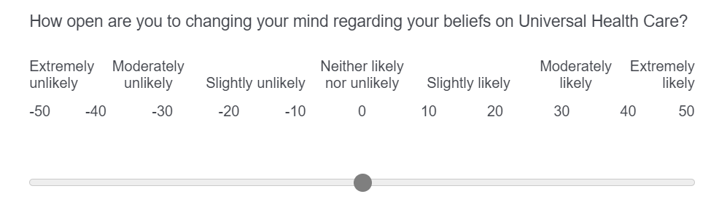

Moral conviction on [Topic] – Example item for UHC

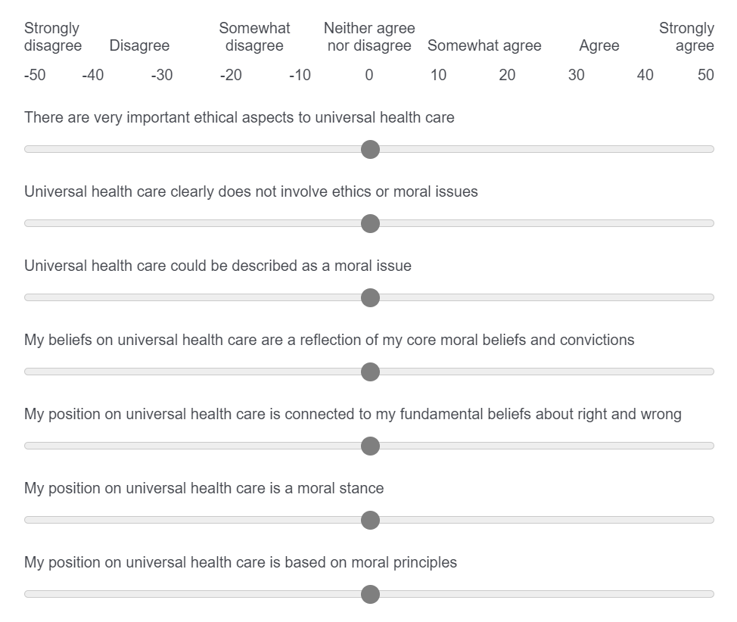

Persuasiveness of Essay on [Topic] - Example item for UHC

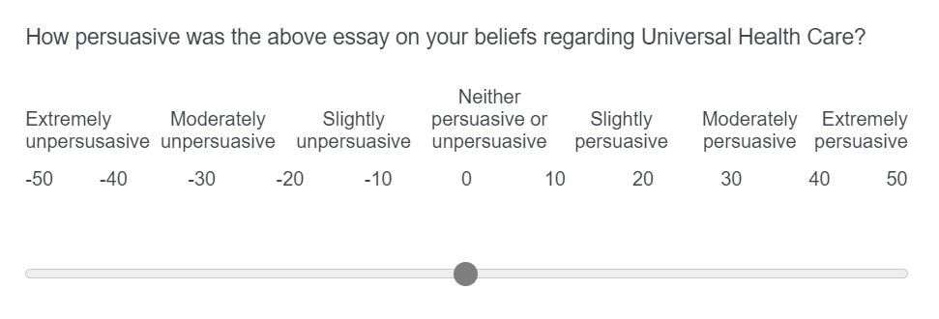

## Appendix C – Materials for Study 3

## Cover Letter

**[Moral Conviction and Recollection of Social Memory on Current and Past Issues]**  
  
  
**Key Information About the Study:**  
  
You are being asked to participate in a research study. The purpose of the research study is to examine how moral conviction towards issues as well as individual differences, affects recollection of past issues.  
  
You are being asked for this study to read a few short essays and pamphlets detailing positions in favor or opposition for various topics. Next, we will have you try to recall what you believe American public sentiment in 2018 was on several social and scientific issues.  
  
Possible benefits include an improved understanding of how moral conviction interacts with changing social perception over time, as well as concrete information about what American public perception in 2018 was like on several critical issues that are still relevant today. Some possible risks may include discomfort from the participant if they feel strongly about and agree or disagree with the arguments either opposing or favoring the three topics we will cover, or discomfort if there is strong disagreement with what was surveyed to be American public opinion in 2018 on several issues.  
  
Please read this form carefully and take your time. Let us know if you have any questions before participating. The research team can explain words or information that you do not understand. Research is voluntary and you can choose not to participate. If you do not want to participate or choose to start then stop later, there will be no penalty or loss of benefits to which you are otherwise entitled.  
  
**Purpose of the Research**  
You are being asked to participate in this study because we believe that differing strengths of moral conviction can affect accuracy in memory recollection. The purpose of the study is to determine if we are able to directly affect the saliency of moral conviction, especially across various topics that are generally considered to have different moral weight, and furthermore, if this affects accuracy of memory recall. You are being asked to participate in a online survey. Specifically, we will ask you to read several short essays and pamphlets, then, we will ask you to predict the extent to which the American public, in 2018, agreed or disagreed with various social and scientific issues. We will also assess individual differences, including moral beliefs, numeracy, and demographic information.  
  
Your participation is expected to last less than 30 minutes.  
  
**What are the expected benefits of the study?**  
We believe the main direct benefit to an individual will be the educational benefit of having accurate understanding of how moral conviction affects recollection of past events. Furthermore, we believe that there will be direct benefits to society as a whole by gleaning a greater understanding of what level of inherent moral conviction our three topics contain. Ideally, this could lead to media coverage of pertinent events being even more easily memorable to the general public, enhancing mass understanding of contemporary issues.  
  
**What are the possible risks of participating in this study?**  
  
There are minimal risks expected when taking part in this study. The most likely risk will be discomfort if our participant strongly disagrees with the information on the  topics that we have presented, or strongly disagrees with the surveyed information on American public opinion we will present. To help lower these possible risks, we will ensure that the information we portray on our topics is as accurate as possible, and that our presentation on American public perception, circa 2018, accurately reflects what we believe to be the 'true' state of social consensus on those issues at that time. We will tell you about any new information we learn that may affect your decision to continue to participate in this study.  
  
**What other choices do I have if I don’t want to be in this study?**  
  
You are not required to be in this study. You can simply choose not to participate. You can look for other research projects you may be interested in instead of this study. You can obtain any number of required Psychology 1000 research credits by instead writing an essay and submitting it to your primary instructor, for each research credit you would like to replace.  
  
**Will I receive compensation for taking part in this study?**  
  
You will be compensated for taking part in this study. For your time and effort, you will receive one research credit for participating in the study. If you choose not to participate in this study, you can still receive the credits by writing an essay on a pre-determined selection of topics (please see your instructor for details).  
  
**Will information about me be kept private?**  
  
The research team is committed to respecting your privacy and keeping your personal information anonymous. We will make every effort to protect your information to the extent allowed by law. When the results of this research are shared, since there is no identifying information it will not be known who provided the information. Your information will be kept as secure as possible to prevent your identity from being disclosed. What we collected from you as part of this research will not be used or shared for future research studies. It will only be used for purposes of this study. We may share what we collected from you as part of this research, for future research without additional informed consent from you.  
  
**Who do I contact if I have questions or concerns?**  
  
If you have questions about this study or experience a research-related injury, you can contact the Primary Investigator at sxdff5@mail.missouri.edu, or at 573-882-6860. If you have questions about your rights as a research participant, please contact the University of Missouri Institutional Review Board (IRB) at 573-882-3181 or muresearchirb@missouri.edu. The IRB is a group of people who review research studies to make sure the rights and welfare of participants are protected. If you want to talk privately about any concerns or issues related to your participation, you may contact the Research Participant Advocacy at 888-280-5002 (a free call) or email muresearchrpa@missouri.edu.  
  
**Do I get a copy of this consent?**  
  
You can ask the researcher to provide you with a copy of this consent for your records, or you can save a copy of this consent if it has already been provided to you. We appreciate your consideration to participate in this study.

## Debrief

**Impact of Moral Conviction on Social Consensus**

Dear Participant,

During this study, you were asked to predict what public approval in 2018 was for several scientific and social issues, as well as to estimate what it would be in current (2024) times. Additionally, we asked you to rate your own level of agreement with the aforementioned issues.

You were told that the purpose of the research study was to examine how moral conviction affects the accuracy of recollections. The actual purpose of the study was to investigate how differing levels of moral conviction interacts with the persuasiveness of a social consensus, and if this persuasion (as well as individual differences in people) could or would have a direct effect on support for Universal Health Care.

We did not tell you everything at the beginning of the study because we were trying to directly determine if outside perception of greater social consensus would 'over-ride' individual preferences one way or another for greater support of Universal Health Care. Furthermore, we wanted to know of differing levels of moral conviction on the topic at hand interacted with the strength of the 'social consensus' effect.

To describe in a simple way, we thought that if we could get you to believe that the general public was in favor of something (which we did by giving you the false feedback) you may become more likely to favor it.

On the second point, the effect of moral conviction in and of itself is also of great interest with regards to decision making, but what does that actually mean? In a simple sense, many people can have various reasons for choosing to support one thing or another, but not all reasoning is made equal.

For example: some people would support abortion access simply because that's what the law is where they live - they don't think about it beyond that, and if the law changed, their stance would change. Some other people would support abortion access because that's what their friends, family, and neighbors believe - if they moved somewhere else, or their social circle changed their mind, their stance could change as well! However, there are definitely some people who support abortion access because they feel deep in their hearts, that it is the 'right' thing to do and is worth fighting for.

Interestingly enough, this could go in both directions! There are people who would care to restrict abortion access that could feel that way for all three of these reasons. Some topics are generally more 'morally loaded' than others, and certainly not everyone agrees as to what topics are even up for ethical debate. We designed this experiment to examine if moral conviction is something that we could change, by providing either a highly moral argument, a non-moral argument, or a factual but mostly neutral 'control' statement.

We predicted that extremely strong moral feelings would prevent people from being affected by social consensus, and that relatively weak moral feelings would result in people being more persuaded by social consensus.

Of note, the actual values from real, recent surveys, circa 2017-2019 are provided below for your edification.  
  
**63%** of the American Public agrees that the US government needs to implement Universal Health Care because basic population needs are not being met.  
  
**60%** of the American Public agrees that Capital Punishment (the Death Penalty) is necessary in the US.  
  
We believe that understanding more deeply how moral conviction interacts with the effect of social consensus will move us forward in our ability to provide Universal Health Care in the United States, as well as expanding our academic understanding of moral decision making more broadly.  
  
Now that you have been told the true purpose of the study, you have the option to have your data removed from the study. Please let the researcher know if you do not want your data to be used in this research and it will be removed.  
  
**The responses in this study cannot be linked to you.**  
  
We would like you to know that we really appreciate your time in helping with this research and are always happy to answer any questions that you might have about it. If you have any concerns about your participation or the data you provided during the study, please discuss these concerns with us. We will be happy to provide you with any explanations or information to ease your concerns. You can reach me by email at sxdff5@mail.missouri.edu.  
  
**Thank you, specifically** for your participation. Really, it helps out a ton! - Sean Duan

If you have questions about your rights as a research participant or want to report a complaint, please contact the Institutional Review Board at the University of Missouri at 573-882-3181, 310 Jesse Hall, Columbia, MO 65211, or at umcresearchcirb@missouri.edu

## Measures